

4500 Rimer Rd, Concord, NC 28025
Church 704-782-8483
A NALC Congregation



Welcome to worship at Cross of Christ!
In the Cross of Christ I glory

Sixth Sunday Of Easter
May 10, 2026

(* Please stand as you are able)

Prelude Our Accompanist Mrs. Yvonne Yost

Greetings and Announcements

*Brief Order For Confession and Forgiveness

P: In the name of the Father, and of the Son, and of the Holy Spirit.
C: Amen

P: Almighty God, to whom all hearts are open, all desires known, and from whom no secrets are hid: Cleanse the thoughts of our hearts by the inspiration of your Holy Spirit, that we may perfectly love you and worthily magnify your holy name, through Jesus Christ our Lord.
C: Amen

P: If we say we have no sin, we deceive ourselves, and the truth is not in us. But if we confess our sins, God who is faithful and just will forgive our sins and cleanse us from all unrighteousness.

Silence for reflection and self-examination.

P: Most merciful God,
C: we confess that we are in bondage to sin and cannot free ourselves. We have sinned against you in thought, word, and deed, by what we have done and by what we have left undone. We have not loved you with our whole heart; we have not loved our neighbors as ourselves. For the sake of your Son, Jesus Christ, have mercy on us. Forgive us, renew us, and lead us, so that we may delight in your will and walk in your ways, to the glory of your holy name. Amen

P: Almighty God, in his mercy, has given his Son to die for us and, for his sake, forgives us all our sins. As a called and ordained minister of the Church of Christ, and by his authority, I therefore declare to you the entire forgiveness of all your sins, in the name of the Father, and of the Son, and of the Holy Spirit.
C: Amen

* Opening Hymn “Great Is Thy Faithfulness” WOV 771

*Apostolic Greeting

P: The grace of our Lord Jesus Christ, the love of God, and the communion of the Holy Spirit be with you all.
C: And also with you.

*Kyrie
*Hymn of Praise: “This is the Feast”

*Salutation
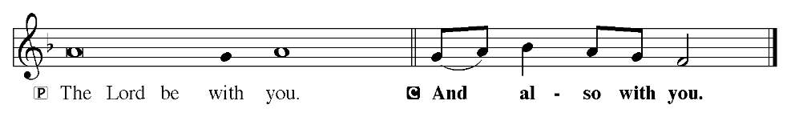
Prayer of the Day
P: O God, all good things can come from you alone; generously consider then our humble prayers. Inspire us to consider what is true and direct us to accomplish what is right; through Jesus Christ, your Son, our Lord. He lives and reigns with you and the Holy Spirit, one God, now and forever.
C: Amen

Children dismissed for children's church

First Reading: Acts 17: 16-31 (ESV)
¹⁶ Now while Paul was waiting for them at Athens, his spirit was provoked within him as he saw that the city was full of idols. ¹⁷ So he reasoned in the synagogue with the Jews and the devout persons, and in the marketplace every day with those who happened to be there. ¹⁸ Some of the Epicurean and Stoic philosophers also conversed with him. And some said, “What does this babbler wish to say?” Others said, “He seems to be a preacher of foreign divinities”—because he was preaching Jesus and the resurrection. ¹⁹ And they took him and brought him to the Areopagus, saying, “May we know what this new teaching is that you are presenting? ²⁰ For you bring some strange things to our ears. We wish to know therefore what these things mean.” ²¹ Now all the Athenians and the foreigners who lived there would spend their time in nothing except telling or hearing something new. ²² So Paul, standing in the midst of the Areopagus, said: “Men of Athens, I perceive that in every way you are very religious. ²³ For as I passed along and observed the objects of your worship, I found also an altar with this inscription: ‘To the unknown god.’ What therefore you worship as unknown, this I proclaim to you. ²⁴ The God who made the world and everything in it, being Lord of heaven and earth, does not live in temples made by man, ²⁵ nor is he served by human hands, as though he needed anything, since he himself gives to all mankind life and breath and everything. ²⁶ And he made from one man every nation of mankind to live on all the face of the earth, having determined allotted periods and the boundaries of their dwelling place, ²⁷ that they should seek God, and perhaps feel their way toward him and find him. Yet he is actually not far from each one of us, ²⁸ for “‘In him we live and move and have our being’; as even some of your own poets have said, “‘For we are indeed his offspring.’ ²⁹ Being then God's offspring, we ought not to think that the divine being is like gold or silver or stone, an image formed by the art and imagination of man. ³⁰ The times of ignorance God overlooked, but now he commands all people everywhere to repent, ³¹ because he has fixed a day on which he will judge the world in righteousness by a man whom he has appointed; and of this he has given assurance to all by raising him from the dead.”

The Word of God for the people of God!
C: Thanks be to God!

PSALM 66: 8-20 (ESV) Read Responsively by Verse
Bless our God, O peoples;
let the sound of his praise be heard,
⁹ who has kept our soul among the living
and has not let our feet slip.
¹⁰ For you, O God, have tested us;
you have tried us as silver is tried.
¹¹ You brought us into the net;
you laid a crushing burden on our backs;
¹² you let men ride over our heads;
we went through fire and through water;
yet you have brought us out to a place of abundance.
¹³ I will come into your house with burnt offerings;
I will perform my vows to you,
¹⁴ that which my lips uttered
and my mouth promised when I was in trouble.
¹⁵ I will offer to you burnt offerings of fattened animals,
with the smoke of the sacrifice of rams;
I will make an offering of bulls and goats.
¹⁶ Come and hear, all you who fear God,
and I will tell what he has done for my soul.
¹⁷ I cried to him with my mouth,
and high praise was on^{[a]} my tongue.^{[b]}
¹⁸ If I had cherished iniquity in my heart,
the Lord would not have listened.
¹⁹ But truly God has listened;
he has attended to the voice of my prayer.
²⁰ Blessed be God,
because he has not rejected my prayer
or removed his steadfast love from me!

Second Reading: 1 Peter 3:13–22 (ESV)

¹³ Now who is there to harm you if you are zealous for what is good? ¹⁴ But even if you should suffer for righteousness' sake, you will be blessed. Have no fear of them, nor be troubled, ¹⁵ but in your hearts honor Christ the Lord as holy, always being prepared to make a defense to anyone who asks you for a reason for the hope that is in you; yet do it with gentleness and respect, ¹⁶ having a good conscience, so that, when you are slandered, those who revile your good behavior in Christ may be put to shame. ¹⁷ For it is better to suffer for doing good, if that should be God's will, than for doing evil. ¹⁸ For Christ also suffered once for sins, the righteous for the unrighteous, that he might bring us to God, being put to death in the flesh but made alive in the spirit, ¹⁹ in which he went and proclaimed to the spirits in prison, ²⁰ because they formerly did not obey, when God's patience waited in the days of Noah, while the ark was being prepared, in which a few, that is, eight persons, were brought safely through water. ²¹ Baptism, which corresponds to this, now saves you, not as a removal of dirt from the body but as an appeal to God for a good conscience, through the resurrection of Jesus Christ, ²² who has gone into heaven and is at the right hand of God, with angels, authorities, and powers having been subjected to him.

The Word of God for the people of God!
C: Thanks be to God!

*Gospel Acclamation
The Holy Gospel according to St. John, the 14th chapter.

*The Holy Gospel: St. John 14: 15-21 (ESV)
¹⁵ “If you love me, you will keep my commandments. ¹⁶ And I will ask the Father, and he will give you another Helper, to be with you forever, ¹⁷ even the Spirit of truth, whom the world cannot receive, because it neither sees him nor knows him. You know him, for he dwells with you and will be in you. ¹⁸ “I will not leave you as orphans; I will come to you. ¹⁹ Yet a little while and the world will see me no more, but you will see me. Because I live, you also will live. ²⁰ In that day you will know that I am in my Father, and you in me, and I in you. ²¹ Whoever has my commandments and keeps them, he it is who loves me. And he who loves me will be loved by my Father, and I will love him and manifest myself to him.”

This is Gospel of our Lord.
Sermon Pastor Carl Haynes

*Sermon Hymn I Was There To Hear Your Borning Cry” WOV 770

The Sacrament of Holy Baptism LBW 121-125
Weston David Drye, son of Matt and Kristi Drye

*Prayer of the Church

Receiving of our Tithes and Offerings

*The Offertory
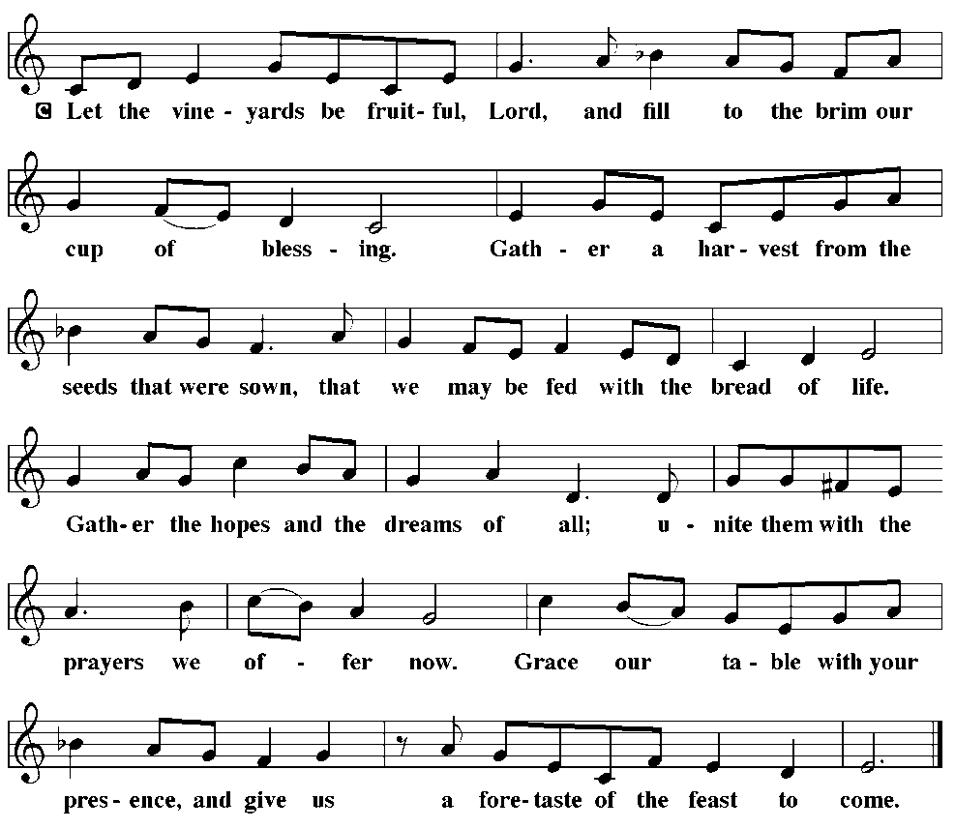
*Offertory Prayer

P: Let us pray. Merciful Father,
C: we offer with joy and thanksgiving what you have first give
us ourselves, our time, and our possessions, signs of your gracious love. Receive them for the sake of him who offered himself for us, Jesus Christ our Lord. Amen

*The Great Thanksgiving
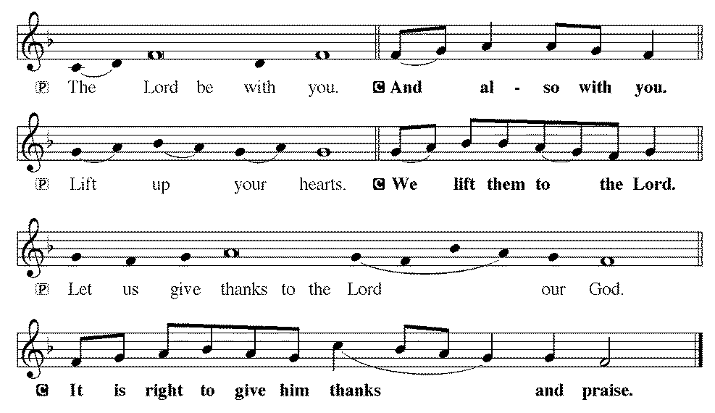

P: It is indeed right and salutary . . . we praise your name and join their unending hymn:
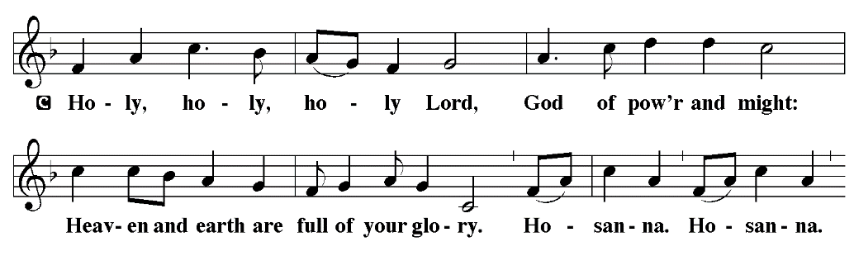
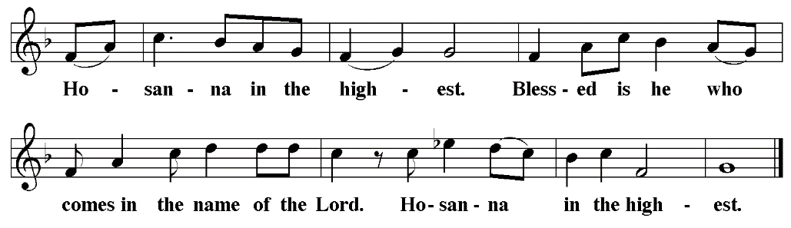

*Words of institution
P: Blessed are you, Lord of heaven and earth.
In mercy for our fallen world you gave your only Son,
that all those who believe in him
should not perish, but have eternal life.
We give thanks to you
for the salvation you have prepared for us through Jesus Christ.
Send now your Holy Spirit into our hearts,
that we may receive our Lord with a living faith
as he comes to us in his holy supper.
C: Amen. Come, Lord Jesus.
In the night in which he was betrayed,
our Lord Jesus took bread, and gave thanks;
broke it, and gave it to his disciples, saying:
Take and eat; this is my body, given for you.
Do this for the remembrance of me.
Again, after supper, he took the cup, gave thanks,
and gave it for all to drink, saying:
This cup is the new covenant in my blood,
shed for you and for all people for the forgiveness of sin.
Do this for the remembrance of me.

*The Lord's Prayer
C: Our Father, who art in heaven, hallowed be thy name,
thy kingdom come,
thy will be done,
on earth as it is in heaven.
Give us this day our daily bread;
and forgive us our trespasses,
as we forgive those who trespass against us;
and lead us not into temptation,
but deliver us from evil.
For thine is the kingdom, and the power, and the glory,
forever and ever. Amen

Administration of the Holy Sacrament
Communion Hymns WOV 740 & 709

*Post Communion Blessing
P: The body and blood of our Lord Jesus Christ
strengthen you and keep you in his grace.
C: Amen

*Post Communion Canticle: “Thank the Lord”
Post Communion Prayer
P: Let us pray. We give you thanks, almighty God, that you have refreshed us through the healing power of this gift of life; and we pray that in your mercy you would strengthen us through this gift, in faith toward you and fervent love toward one another; for the sake of Jesus Christ our Lord.
C: Amen

*Benediction
P: The Lord bless you and keep you.
The Lord make his face shine on you and be gracious to you.
The Lord look upon you with favor, and give you peace.
C: Amen

*Sending Hymn “Blessed Assurance" WOV 699

*Dismissal
P: Go in peace. Serve the Lord.
C: Thanks be to God.

*Postlude
Used by permission of Augsburg Fortress under license # SB127756.

The Altar Flowers are given to the Glory of God and in honor of Mother’s Day by Larry Barbee.

We would like to thank Pastor Haynes for leading our service today.

This Saturday is the Car, Truck & Bike Show along the monthly breakfast from 7:00 to 10:00. Hotdogs will be available for lunch from 11:00 to 1:00. Come on out and bring your family and friends to join us.

Car Show reminders and Thank You’s

- Sponsorships & Donations - Thank you to all the who provided a sponsorship or donation for the event
- Parking Volunteers – Please be at church at 6:15am and pick up your equipment in the Admin Conference Room. There will be a short meeting at 6:25am in the Conference Room.
- Registration Volunteers – Please be at church by 6:30am at the Registration Tables (setup outside the Admin Building).
- All Volunteers (Car Show and Breakfast) – Please remember to park on the Ball Field so that all available pavement space is reserved for Car Show participants/attendees and those attending the Breakfast.
The PBnJ Youth Group will meet next Sunday, May 17th at 3:30.

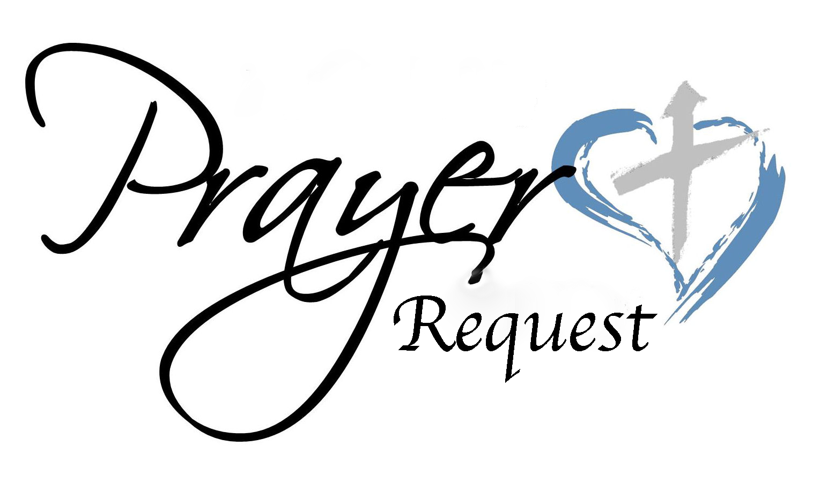
May 10, 2026
We ask that you always have an individual’s permission before
requesting their name be added to our Prayer List.
Please send prayer list request additions or changes to
prayercclc@gmail.com by Tuesday 5PM.

First of all, then, I urge that supplications, prayers, intercessions, and thanksgivings be made for all people… 1Timothy 2:1

In the Fellowship of Cross of Christ
Betty Archer; James Bailey (Rotator cuff surgery recovery); Joann Barrier; Melvin Bost; Roy Gray (Knee replacement surgery on 5/11/26)

Call Process prayer requests: 1) Cross of Christ Church; 2) Call Committee; 3) Prospective pastors see our profile/video and consider a call here.

Shut-Ins
Bob Barrier; Brenda Barrier; Norman Goodman; Nell Hatley; John Trull.

Friends of Cross of Christ
Addie Drye; April Funderburke; Lee Gorforth; Candice Horton;
Cynthia Horton; Alicia McQueen; Eric Starling (Husband of Susan Starling – Baptist Hospital – Infection affecting much of his body); Susan Starling; Daniel Pless; Jacob Rodgers; Nick Smith; Melanie Thrift; Max Vanderburg; Bob Wilson; Candace Yates

Carolina Mission Region Seminarians:
Melanie Corn, Robert Dernbach, Lucas Safrit

Serving in the Military
Eaven Allison (Fairbanks, Alaska)

General Prayer Concerns:
· Ongoing Iran war impacts
· Prayers for additional rain

** Please remember our shut-ins with a visit, phone call, card, or email along with your prayers

Today May 10,2026
Happy Mother’s Day!

Holy Communion Service 10:00 AM

This Week
MON: 7 – 8:30 PM Soldiers of the Cross of Christ Practice
SAT: 7 – 10:00 AM Breakfast/11 – 1:00 PM Lunch
Spring Car, Truck & Bike Show

NEXT SUNDAY
9:00 AM Sunday Church School Classes
10:00 AM Family Worship Service

Next Sunday's Readings
Seventh Day of Easter
Acts 1:12-26
Psalm 68.: 1-10
1 Peter 4:12-19; 5:6-11
St. John 171: 1-11

www.crossofchristlutheranchurch.org http://www.facebook.com/CrossofChristLutheranChurchConcord
ClericalTeam@Gmail.com
prayercclc@gmail.com

