*Cross of Christ Lutheran Church*

*­­­­* 4500 Rimer Rd, Concord, NC 28025

*Church 704-782-8483 Parish Hall 704-795-0445*

*Parsonage 704-786-3643*

*The Rev. Rafe Allison, Pastor*

*A NALC Congregation*



Welcome to worship at Cross of Christ!

In the Cross of Christ I glory 

*Fifth Sunday of Pentecost*

*July 2, 2023*

Our Accompanist Mrs. Yvonne Yost

Greetings and Announcements

*Brief Order For Confession and Forgiveness

In the name of the Father, and of the  Son, and of the Holy Spirit.

**Amen**

God of all mercy and consolation, come to the aid of your people, turning us from our sin to live for you alone. Give us the power of your Holy Spirit that, attentive to your Word, we may confess our sins, receive your forgiveness, and grow into the fullness of your Son, Jesus Christ our Lord.

**Amen**

Let us confess our sin in the presence of God and of one another.

*Silence for reflection and self-examination.*

Gracious God,

**have mercy on us. In your compassion forgive us our sins, known and unknown, things done and left undone. Uphold us by your Spirit so that we may live and serve you in newness of life, to the honor and glory of your holy name; through Jesus Christ our Lord. Amen**

Almighty God have mercy on you, forgive you all your sins, through our Lord Jesus Christ, strengthen you in all goodness, and by the power of the Holy Spirit keep you in eternal life. In the name of the Father, and of the  Son, and of the Holy Spirit.

**Amen**

* Opening Hymn  ***“Onward Christian Soldiers”*LBW 509**

*Apostolic Greeting

The grace of our Lord Jesus Christ, the love of God, and the communion of the Holy Spirit be with you all.

**And also with you.**

*Hymn of Praise: *“Glory to God”* 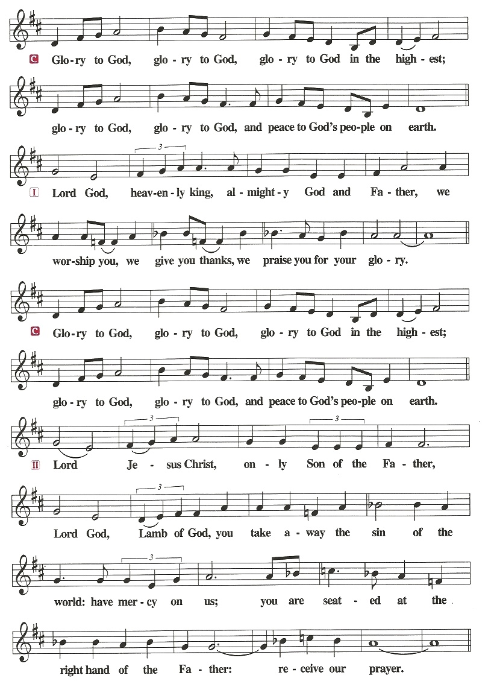

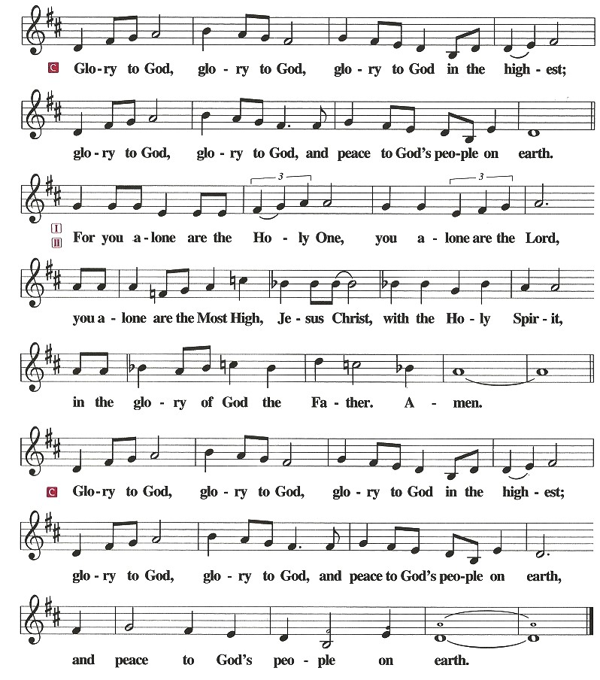

*Salutation & Prayer of the Day

The Lord be with you.

**And also with you.**

**\***Prayer of the Day

Let us pray. God, our maker and redeemer,

**you have made us a new company of priests to bear witness to the Gospel. Enable us to be faithful to our calling to make known your promises to all the world; through your Son, Jesus Christ our Lord. Amen.**

Children dismissed for children's church

**First Reading: Jeremiah 28: 5-9 (ESV)**

**5**Then the prophet Jeremiah spoke to Hananiah the prophet in the presence of the priests and all the people who were standing in the house of the Lord, **6**and the prophet Jeremiah said, “Amen! May the Lord do so; may the Lord make the words that you have prophesied come true, and bring back to this place from Babylon the vessels of the house of the Lord, and all the exiles. **7**Yet hear now this word that I speak in your hearing and in the hearing of all the people. **8**The prophets who preceded you and me from ancient times prophesied war, famine, and pestilence against many countries and great kingdoms. **9**As for the prophet who prophesies peace, when the word of that prophet comes to pass, then it will be known that the Lord has truly sent the prophet.”

The Word of God for the people of God!

**Thanks be to God!**

**Psalm 119: 153-160 Read Responsively by Verse**

**153**Look on my affliction and deliver me,  
    for I do not forget your law.  
**154Plead my cause and redeem me;  
    give me life according to your promise!  
155**Salvation is far from the wicked,  
    for they do not seek your statutes.  
**156Great is your mercy, O Lord;  
    give me life according to your rules.  
157**Many are my persecutors and my adversaries,  
    but I do not swerve from your testimonies.  
**158I look at the faithless with disgust,  
    because they do not keep your commands.  
159**Consider how I love your precepts!  
    Give me life according to your steadfast love.  
**160The sum of your word is truth,  
    and every one of your righteous rules endures forever.**

**Second Reading: Romans 7: 1-13 (ESV)**

Or do you not know, brothers—for I am speaking to those who know the law—that the law is binding on a person only as long as he lives? **2**For a married woman is bound by law to her husband while he lives, but if her husband dies she is released from the law of marriage. **3**Accordingly, she will be called an adulteress if she lives with another man while her husband is alive. But if her husband dies, she is free from that law, and if she marries another man she is not an adulteress. **4**Likewise, my brothers, you also have died to the law through the body of Christ, so that you may belong to another, to him who has been raised from the dead, in order that we may bear fruit for God. **5**For while we were living in the flesh, our sinful passions, aroused by the law, were at work in our members to bear fruit for death. **6**But now we are released from the law, having died to that which held us captive, so that we serve in the new way of the Spirit and not in the old way of the written code. **7**What then shall we say? That the law is sin? By no means! Yet if it had not been for the law, I would not have known sin. For I would not have known what it is to covet if the law had not said, “You shall not covet.” **8**But sin, seizing an opportunity through the commandment, produced in me all kinds of covetousness. For apart from the law, sin lies dead. **9**I was once alive apart from the law, but when the commandment came, sin came alive and I died. **10**The very commandment that promised life proved to be death to me. **11**For sin, seizing an opportunity through the commandment, deceived me and through it killed me. **12**So the law is holy, and the commandment is holy and righteous and good.**13**Did that which is good, then, bring death to me? By no means! It was sin, producing death in me through what is good, in order that sin might be shown to be sin, and through the commandment might become sinful beyond measure.

The Word of God for the people of God!

**Thanks be to God!**

# *Gospel Acclamation

The Holy Gospel according to St. Matthew, the 10th chapter.

**Glory to you, O Lord.**

# The Holy Gospel: St. Matthew 10: 34-42 (ESV)

# 34“Do not think that I have come to bring peace to the earth. I have not come to bring peace, but a sword. 35For I have come to set a man against his father, and a daughter against her mother, and a daughter-in-law against her mother-in-law. 36And a person's enemies will be those of his own household. 37Whoever loves father or mother more than me is not worthy of me, and whoever loves son or daughter more than me is not worthy of me. 38And whoever does not take his cross and follow me is not worthy of me. 39Whoever finds his life will lose it, and whoever loses his life for my sake will find it.40“Whoever receives you receives me, and whoever receives me receives him who sent me. 41The one who receives a prophet because he is a prophet will receive a prophet's reward, and the one who receives a righteous person because he is a righteous person will receive a righteous person's reward. 42And whoever gives one of these little ones even a cup of cold water because he is a disciple, truly, I say to you, he will by no means lose his reward.”

This is Gospel of our Lord.

**Praise to you, O Christ.**

sermon Pastor Rafe Allison

*Sermon Hymn ***“My Country Tis Of Thee****”* **LBW 566**

*Apostles' Creed

**I believe in God, the Father almighty,**

**creator of heaven and earth.**

**I believe in Jesus Christ, his only Son, our Lord.**

**He was conceived by the power of the Holy Spirit**

**and born of the virgin Mary.**

**He suffered under Pontius Pilate,**

**was crucified, died, and was buried.**

**He descended into hell.**

**On the third day he rose again.**

**He ascended into heaven,**

**and is seated at the right hand of the Father.**

**He will come again to judge the living and the dead.**

**I believe in the Holy Spirit,**

**the holy catholic Church,**

**the communion of saints,**

**the forgiveness of sins,**

**the resurrection of the body,**

**and the life everlasting. Amen**

*Prayer of the Church

*Receiving of our Tithes and Offerings

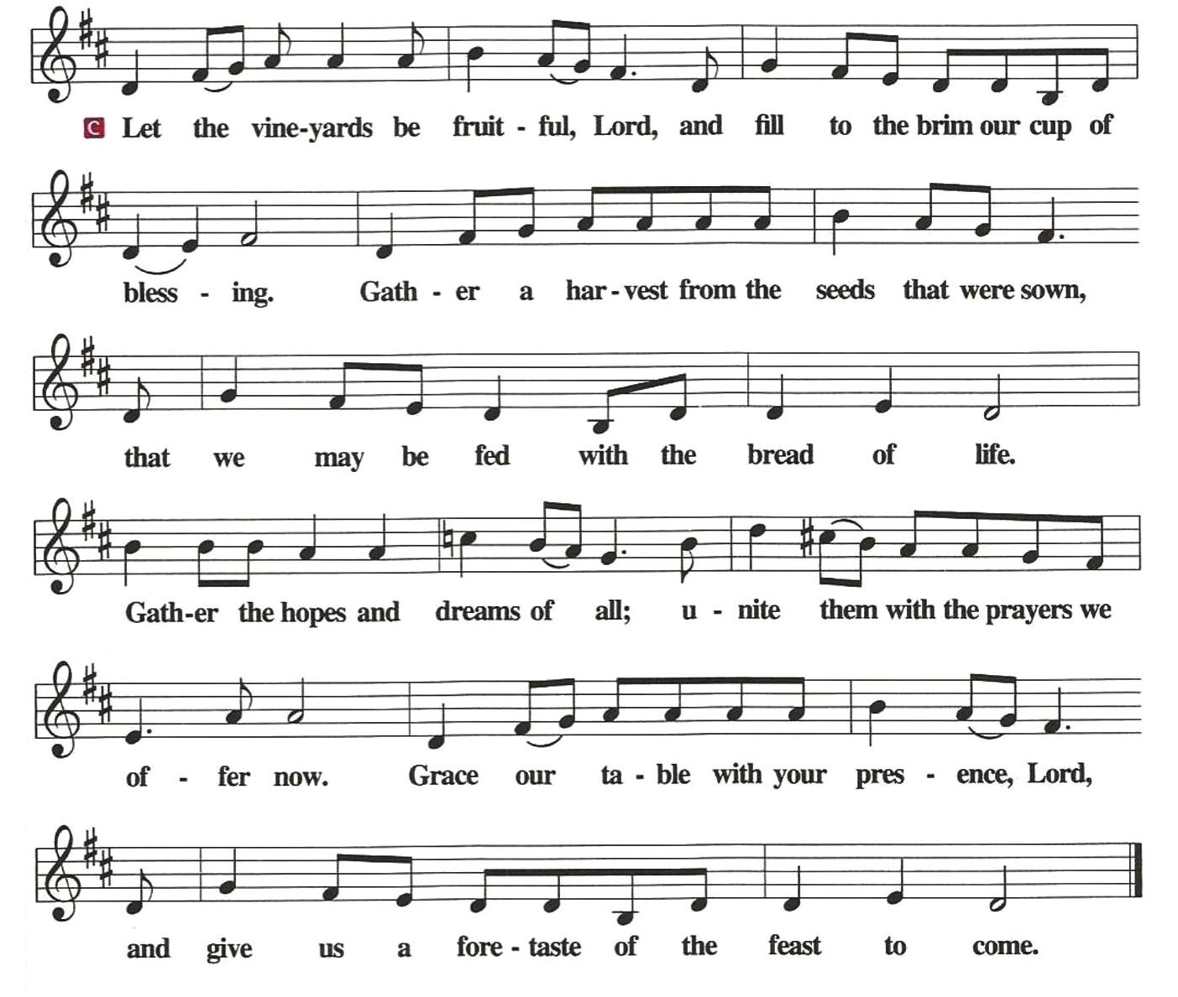*The Offertory

*Offertory Prayer

Let us pray. Merciful Father,

**we offer with joy and thanksgiving what you have first given us-- ourselves, our time, and our possessions, signs of your gracious love. Receive them for the sake of him who offered himself for us, Jesus Christ our Lord. Amen**

*The Great Thanksgiving

The Lord be with you

**And also with you.**

Lift up your hearts.

**We lift them to the Lord.**

Let us give thanks to the Lord our God.

**It is right to give Him thanks and praise.**

It is indeed right and salutary...we praise your name and

join their unending hymn:

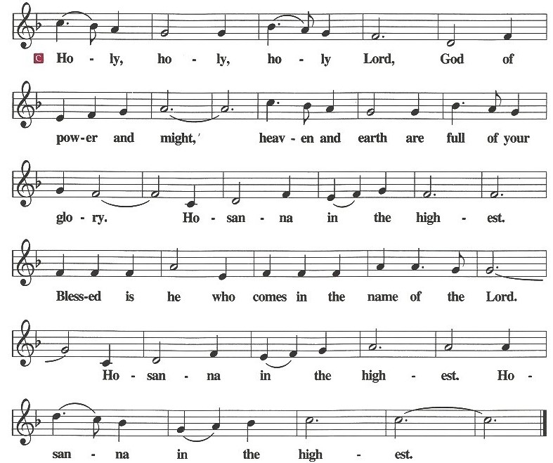

**\*Eucharistic Prayer & Words of institution**

Blessed are you, Lord of heaven and earth.

In mercy for our fallen world you gave your only Son,

that all those who believe in him

should not perish, but have eternal life.

We give thanks to you

for the salvation you have prepared for us through Jesus Christ.

Send now your Holy Spirit into our hearts,

that we may receive our Lord with a living faith

as he comes to us in his holy supper.

**Amen. Come, Lord Jesus.**

In the night in which he was betrayed,

our Lord Jesus took bread, and gave thanks;

broke it, and gave it to his disciples, saying:

Take and eat; this is my body, given for you.

Do this for the remembrance of me.

Again, after supper, he took the cup, gave thanks,

and gave it for all to drink, saying:

This cup is the new covenant in my blood,

shed for you and for all people for the forgiveness of sin.

Do this for the remembrance of me.

*The Lord's Prayer

**Our Father, who art in heaven, hallowed be thy name,**

**thy kingdom come,**

**thy will be done,**

**on earth as it is in heaven.**

**Give us this day our daily bread;**

**and forgive us our trespasses,**

**as we forgive those who trespass against us;**

**and lead us not into temptation,**

**but deliver us from evil.**

**For thine is the kingdom, and the power, and the glory,**

**forever and ever. Amen**

Administration of the Holy Sacrament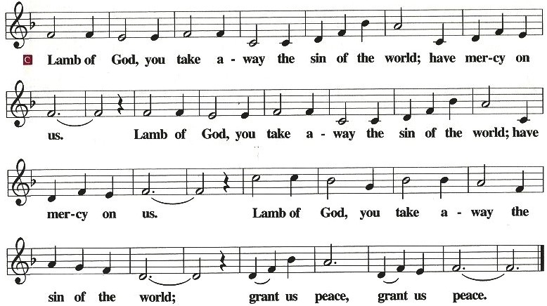

Communion Hymns **WOV 740 & 709**

*Post Communion Blessing

The body and blood of our Lord Jesus Christ

strengthen you and keep you in his grace.

**Amen**

*Post Communion Canticle: *“Thank the Lord”*

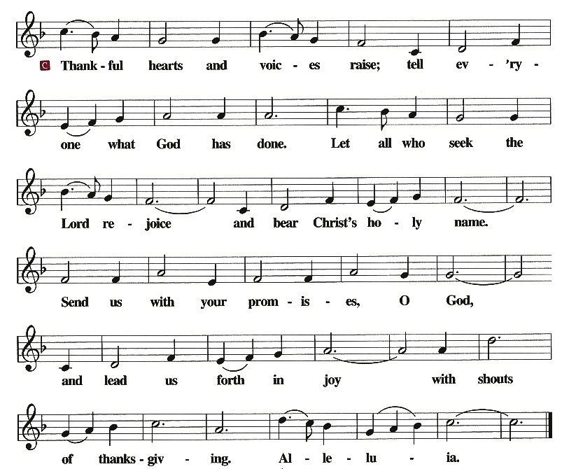

*Post Communion Prayer

Let us pray. We give you thanks, almighty God, that you have refreshed us through the healing power of this gift of life; and we pray that in your mercy you would strengthen us through this gift, in faith toward you and fervent love toward one another; for the sake of Jesus Christ our Lord.

**Amen**

*Benediction

The Lord bless you and keep you.

The Lord make his face shine on you and be gracious to you.

The Lord look upon you with favor and give you peace.

**Amen**

*Sending Hymn ***“Battle Hymn Of The Republic”*****LBW 332**

*Dismissal

Go in peace. Serve the Lord.

**Thanks be to God.**

*Postlude **(* *Please stand as you are able*)**

*Used by permission of Augsburg Fortress under license # SB127756*

The **Altar Flowers** are given to the Glory of God and in the honor and memory of all fallen heroes by the Sverko family.

**Community Outreach** is sponsoring a blood drive with ONE BLOOD **NEXT Sunday July 9th** starting after service on the Big Red Bus. Please see Jodie Strube to sign up.

**Community Outreach** is asking for donations for Mt. Pleasant Food Pantry for the Sundays of **6.18 – 7.9.** The needs are as follows: Tomato soup, Canned Pasta (spaghettios, ravioli, etc), Cereal, Pasta Sauce, Pancake mix and syrup. Thank you for providing for those in need.

**Youth Sunday** is on July 30th.

|  |
| --- |
| **Weekly Offering Report For:**  **Week No: 26 Date: June 15, 2023**  2023 Weekly Needs: $3,674.98 YTD Budget Needs: $95,549.48  **Last Week**  General Tithes Received $4,180.00 YTD Gen. Tithes Received $94,127.00 Last week Above Needs $ 505.02 YTD (Deficit) ($1,422.48) |



**July 2, 2023**

***A little reminder about our prayer list.***

***We ask that you always have an individual’s permission***

***before requesting their name be added to our Prayer List.***

***Contact Pastor Allison or Prayer List Coordinator Belinda Campbell***

***to request additions or changes.***

*First of all, then, I urge that supplications, prayers, intercessions,*

*and thanksgivings be made for all people…  1Timothy 2:1*

**In the Fellowship of Cross of Christ**

John Faggart; Joyce Harkins; Candice Horton; Doris & Frank Kluttz; Carl Pless; Carson Seagraves (Recovery from knee repair surgery on 6/21/2023); John & Linda Trull; Dot Weast; Rand Yost.

**Serving in the Military**

Eaven Allison (Okinawa, Japan)

**Friends of Cross of Christ**

Veronica Barber and family and fiancée Jeff; David Buckland;

LeaAnne Buckwell; Delores Carpenter; Mary Cox;

Steve & Angie Dixon; Alisa Erts; Jane Faggart; Pastor Jeff Faggart; Wanda Floyd; Joyce Furr; Ralph Furr; Alley Handy; Brandon Lewis; Kaye and Gerry Litzinger; Ensley Morgan; Karen Morgan; Steve Parker; Ronnie Procter; Lettie Reid (Mother of Joyce R. Pless – experiencing a very painful time with shingles); Susan Starling;

Connie Walters; Candace Yates; Vickey Belk Young

**General Prayer Concerns**

**Praise List:**

**\*\* Please remember our shut-ins with a visit, phone call,**

**cards, or email along with your prayers**

**Today – July 2, 2023**

Sunday Church School 9:00 AM

Holy Communion Service 10:00 AM

***This Week***

TUES: ***HAPPY JULY 4TH!!!***

***NEXT SUNDAY***

9:00 AM Sunday Church School Classes

10:00 AM Family Worship Service

11:00 AM – 3:30 PM Blood Drive

***Next Sunday's Readings***

*Twenty-third Sunday after Pentecost*

Malachi 4: 1-6

Psalm 98

2 Thessalonians 3: 1-13

St. Luke 21: 5-28

***Next Sunday's Readings***

*Twenty-third Sunday after Pentecost*

Malachi 4: 1-6

Psalm 98

2 Thessalonians 3: 1-13

St. Luke 21: 5-28

***Next Sunday's Readings***

*Sixth Sunday of Pentecost*

Zechariah 9: 9-12

Psalm 145: 1-14

Romans 7: 14-25a

St. Matthew 11: 25-30

***Next Sunday's Readings***

*Twenty-third Sunday after Pentecost*

Malachi 4: 1-6

Psalm 98

2 Thessalonians 3: 1-13

St. Luke 21: 5-28

***Next Sunday's Readings***

*Twenty-third Sunday after Pentecost*

Malachi 4: 1-6

Psalm 98

2 Thessalonians 3: 1-13

St. Luke 21: 5-28

***Next Sunday's Readings***

*Twenty-third Sunday after Pentecost*

Malachi 4: 1-6

Psalm 98

2 Thessalonians 3: 1-13

St. Luke 21: 5-28

***Next Sunday's Readings***

*Twenty-third Sunday after Pentecost*

Malachi 4: 1-6

Psalm 98

2 Thessalonians 3: 1-13

St. Luke 21: 5-28

***Next Sunday's Readings***

*Twenty-third Sunday after Pentecost*

Malachi 4: 1-6

Psalm 98

2 Thessalonians 3: 1-13

St. Luke 21: 5-28

www.crossofchristlutheranchurch.org

http://www.facebook.com/CrossofChristLutheranChurchConcord

ClericalTeam@Gmail.com