

4500 Rimer Rd, Concord, NC 28025
Church 704-782-8483

A NALC Congregation



Welcome to worship at Cross of Christ!
In the Cross of Christ I glory

Eleventh Sunday After Pentecost
August 9, 2026

(* Please stand as you are able)

Prelude Our Accompanist Mrs. Yvonne Yost

Greetings and Announcements

*Brief Order For Confession and Forgiveness

P: In the name of the Father, and of the Son, and of the Holy Spirit.
C: Amen

P: Almighty God, to whom all hearts are open, all desires known, and from whom no secrets are hid: Cleanse the thoughts of our hearts by the inspiration of your Holy Spirit, that we may perfectly love you and worthily magnify your holy name, through Jesus Christ our Lord.
C: Amen

P: If we say we have no sin, we deceive ourselves, and the truth is not in us. But if we confess our sins, God who is faithful and just will forgive our sins and cleanse us from all unrighteousness.

Silence for reflection and self-examination.

P: Most merciful God,
C: we confess that we are in bondage to sin and cannot free ourselves. We have sinned against you in thought, word, and deed, by what we have done and by what we have left undone. We have not loved you with our whole heart; we have not loved our neighbors as ourselves. For the sake of your Son, Jesus Christ, have mercy on us. Forgive us, renew us, and lead us, so that we may delight in your will and walk in your ways, to the glory of your holy name. Amen

P: Almighty God, in his mercy, has given his Son to die for us and, for his sake, forgives us all our sins. As a called and ordained minister of the Church of Christ, and by his authority, I therefore declare to you the entire forgiveness of all your sins, in the name of the Father, and of the Son, and of the Holy Spirit.

C: Amen

* Opening Hymn “O Worship The King ” LBW 548

vs 1-4

*Apostolic Greeting
P: The grace of our Lord Jesus Christ, the love of God, and the communion of the Holy Spirit be with you all.
C: And also with you.

*Hymn of Praise: “Glory to God”

*Salutation
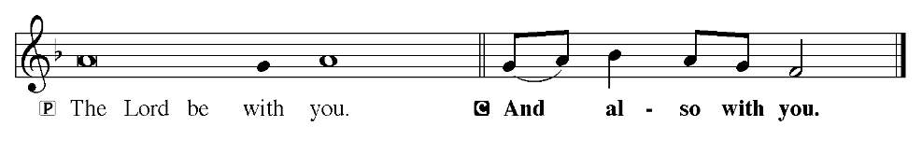

*Prayer of the Day

P: Let us pray. Almighty and merciful God, only by your gift of grace can the faithful offer service that is worthy of you and deserving of praise. Keep us from stumbling as we run to receive your promises; through Jesus Christ, your Son, our Lord, who lives and reigns with you and the Holy Spirit, one God, now and forever.

C: Amen

Children dismissed for children's church

First Reading: Job 38: 1-18 (ESV)

Then the Lord answered Job out of the whirlwind and said:
² “Who is this that darkens counsel by words without knowledge?
³ Dress for action like a man;
I will question you, and you make it known to me.
⁴ “Where were you when I laid the foundation of the earth?
Tell me, if you have understanding.
⁵ Who determined its measurements—surely you know!
Or who stretched the line upon it?
⁶ On what were its bases sunk,
or who laid its cornerstone,
⁷ when the morning stars sang together
and all the sons of God shouted for joy?
⁸ “Or who shut in the sea with doors
when it burst out from the womb,
⁹ when I made clouds its garment
and thick darkness its swaddling band,
¹⁰ and prescribed limits for it
and set bars and doors,
¹¹ and said, ‘Thus far shall you come, and no farther,
and here shall your proud waves be stayed’?
¹² “Have you commanded the morning since your days began,
and caused the dawn to know its place,
¹³ that it might take hold of the skirts of the earth,
and the wicked be shaken out of it?
¹⁴ It is changed like clay under the seal,
and its features stand out like a garment.
¹⁵ From the wicked their light is withheld,
and their uplifted arm is broken.
¹⁶ “Have you entered into the springs of the sea,
or walked in the recesses of the deep?
¹⁷ Have the gates of death been revealed to you,
or have you seen the gates of deep darkness?
¹⁸ Have you comprehended the expanse of the earth?
Declare, if you know all this.

The Word of God for the people of God!
C: Thanks be to God!

Psalm 18: 1-16 (ESV) Read Responsively by Verse
I love you, O Lord, my strength.
² The Lord is my rock and my fortress and my deliverer,
my God, my rock, in whom I take refuge,
my shield, and the horn of my salvation, my stronghold.
³ I call upon the Lord, who is worthy to be praised,
and I am saved from my enemies.
⁴ The cords of death encompassed me;
the torrents of destruction assailed me;
⁵ the cords of Sheol entangled me;
the snares of death confronted me.
⁶ In my distress I called upon the Lord;
to my God I cried for help.
From his temple he heard my voice,
and my cry to him reached his ears.
⁷ Then the earth reeled and rocked;
the foundations also of the mountains trembled
and quaked, because he was angry.
⁸ Smoke went up from his nostrils,
and devouring fire from his mouth;
glowing coals flamed forth from him.
⁹ He bowed the heavens and came down;
thick darkness was under his feet.
¹⁰ He rode on a cherub and flew;
he came swiftly on the wings of the wind.
¹¹ He made darkness his covering, his canopy around him,
thick clouds dark with water.
¹² Out of the brightness before him
hailstones and coals of fire broke through his clouds.
¹³ The Lord also thundered in the heavens,
and the Most High uttered his voice,
hailstones and coals of fire.
¹⁴ And he sent out his arrows and scattered them;
he flashed forth lightnings and routed them.
¹⁵ Then the channels of the sea were seen,
and the foundations of the world were laid bare
at your rebuke, O Lord,
at the blast of the breath of your nostrils.
¹⁶ He sent from on high, he took me;
he drew me out of many waters.

Second Reading: Romans 10: 5-17 (ESV)

⁵ For Moses writes about the righteousness that is based on the law, that the person who does the commandments shall live by them. ⁶ But the righteousness based on faith says, “Do not say in your heart, ‘Who will ascend into heaven?’” (that is, to bring Christ down) ⁷ “or ‘Who will descend into the abyss?’” (that is, to bring Christ up from the dead). ⁸ But what does it say? “The word is near you, in your mouth and in your heart” (that is, the word of faith that we proclaim); ⁹ because, if you confess with your mouth that Jesus is Lord and believe in your heart that God raised him from the dead, you will be saved. ¹⁰ For with the heart one believes and is justified, and with the mouth one confesses and is saved. ¹¹ For the Scripture says, “Everyone who believes in him will not be put to shame.” ¹² For there is no distinction between Jew and Greek; for the same Lord is Lord of all, bestowing his riches on all who call on him. ¹³ For “everyone who calls on the name of the Lord will be saved.”¹⁴ How then will they call on him in whom they have not believed? And how are they to believe in him of whom they have never heard? And how are they to hear without someone preaching? ¹⁵ And how are they to preach unless they are sent? As it is written, “How beautiful are the feet of those who preach the good news!” ¹⁶ But they have not all obeyed the gospel. For Isaiah says, “Lord, who has believed what he has heard from us?” ¹⁷ So faith comes from hearing, and hearing through the word of Christ.

The Word of God for the people of God!
C: Thanks be to God!

*Gospel Acclamation

P: The Holy Gospel according to St. Matthew, 14th chapter.

*The Holy Gospel: St. Matthew 14: 22-33 (ESV)

²² Immediately he made the disciples get into the boat and go before him to the other side, while he dismissed the crowds. ²³ And after he had dismissed the crowds, he went up on the mountain by himself to pray. When evening came, he was there alone, ²⁴ but the boat by this time was a long way from the land, beaten by the waves, for the wind was against them. ²⁵ And in the fourth watch of the night he came to them, walking on the sea. ²⁶ But when the disciples saw him walking on the sea, they were terrified, and said, “It is a ghost!” and they cried out in fear. ²⁷ But immediately Jesus spoke to them, saying, “Take heart; it is I. Do not be afraid.” ²⁸ And Peter answered him, “Lord, if it is you, command me to come to you on the water.” ²⁹ He said, “Come.” So Peter got out of the boat and walked on the water and came to Jesus. ³⁰ But when he saw the wind, he was afraid, and beginning to sink he cried out, “Lord, save me.” ³¹ Jesus immediately reached out his hand and took hold of him, saying to him, “O you of little faith, why did you doubt?” ³² And when they got into the boat, the wind ceased. ³³ And those in the boat worshiped him, saying, “Truly you are the Son of God.”

P: This is Gospel of our Lord.

Sermon Pastor George Rhyne

*Sermon Hymn “Beautiful Savior” LBW 518

*Apostles' Creed
I believe in God, the Father almighty,
creator of heaven and earth.
I believe in Jesus Christ, his only Son, our Lord.
He was conceived by the power of the Holy Spirit
and born of the virgin Mary.
He suffered under Pontius Pilate,
was crucified, died, and was buried.
He descended into hell.
On the third day he rose again.
He ascended into heaven,
and is seated at the right hand of the Father.
He will come again to judge the living and the dead.
I believe in the Holy Spirit,
the holy catholic Church,
the communion of saints,
the forgiveness of sins,
the resurrection of the body,
and the life everlasting. Amen
*Receiving of our Tithes and Offerings
*The Offertory

*Prayer of the Church

*The Lord's Prayer
Our Father, who art in heaven, hallowed be thy name,
thy kingdom come,
thy will be done,
on earth as it is in heaven.
Give us this day our daily bread;
and forgive us our trespasses,
as we forgive those who trespass against us;
and lead us not into temptation,
but deliver us from evil.
For thine is the kingdom, and the power, and the glory,
forever and ever. Amen

*Benediction
P: The Lord bless you and keep you.
The Lord make his face shine on you and be gracious to you.
The Lord look upon you with favor, and give you peace.
C: Amen

*Sending Hymn “When Peace Like A River” LBW 346
(Chorus: It is well (it is well) with my soul (with my soul);
it is well, it is well with my soul.

*Dismissal
P: Go in peace. Serve the Lord.
C: Thanks be to God.

*Postlude

Used by permission of Augsburg Fortress under license # SB127756.

The Altar Flowers are given to the Glory of God and in honor of Sharon Barbee’s birthday by her family.
We would like to thank Pastor George Rhyne for leading our service today.
The PBnJ and CSI youth groups will meet this afternoon at 3:30 PM
Our monthly fundraiser breakfast is this Saturday, August 15th. Come on out for a delicious country breakfast & fellowship with us!!

Birthday Bags for Coltrane Life Center: The PBnJ Youth Group will be continuing with their birthday bags for the Coltrane Life Center participants through the end of the year. Earlier in the year we completed May - August bags. We are in need of the following items: Word Searches, Coloring Books, Ink Pens, Colored Pencils, $5 Gift Cards to places like Hardee's or Chick Fil A, Individual packs of Kleenex, Small Lotions, Colored Paper “Lunch” Bags or Small Birthday Bags. Thank you for your help with this project.

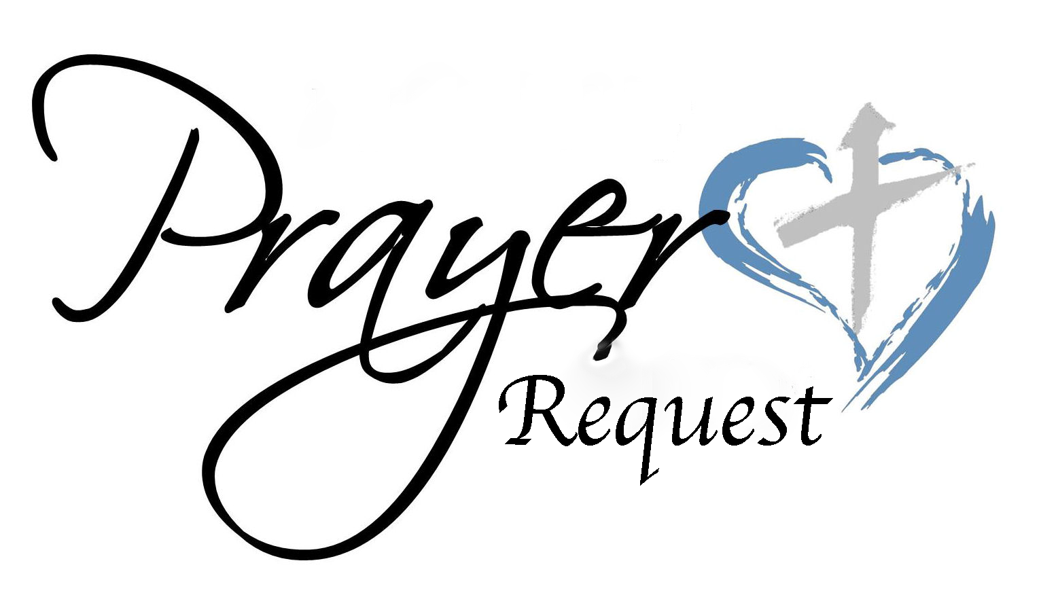August 9, 2026
We ask that you always have an individual’s permission before
requesting their name be added to our Prayer List.
Please send prayer list request additions or changes to
prayercclc@gmail.com by Tuesday 5PM.

First of all, then, I urge that supplications, prayers, intercessions, and thanksgivings be made for all people… 1Timothy 2:1

In the Fellowship of Cross of Christ
Brenda Barrier; Wayne Peck; Carl Pless, Jr.; Rand Yost
Call Process prayer requests: 1) Cross of Christ Church; 2) Call Committee; 3) Prospective pastors see our profile/video and consider a call here.

Shut-Ins
Bob and Joann Barrier; Norman Goodman; Nell Hatley; John Trull.

Friends of Cross of Christ
Carolyn Campbell; Bill Dickens; Josh Fabricius; April Funderburke;
Lee Gorforth; Cathy Heminger; Nicholas Hildebrandt’s Wife and 2 children in accident on 8/6/26 (Cousin of Amanda Faggart);
Candice Horton; Cynthia Horton; Gloria Mann (Aunt of Susan Caudle – Cancer diagnosis received); Alicia McQueen; Jameson Nichols;
Hayden Polakowski; Eric Starling; Susan Starling; Ruthie O’Brien; Daniel Pless; Jacob Rodgers; Nick Smith; Bob Wilson; Candace Yates

Carolina Mission Region Seminarians: Melanie Corn, Robert Dernbach, Lucas Safrit

Serving in the Military
Eaven Allison (Fairbanks, Alaska)

General Prayer Concerns:
· Ongoing Iran war impacts

** Please remember our shut-ins with a visit, phone call, card, or email along with your prayers
Today August 9, 2026
Sunday Church School 9:00 AM
Family Worship Service 10:00 AM

This Week

MON: 7 – 8:30 PM Soldiers of the Cross of Christ Practice
SAT: Monthly Breakfast 7:00-11:00 AM

NEXT SUNDAY
9:00 AM Sunday Church School Classes
10:00 AM Family Worship Service

Next Sunday's Readings
Twelfth Sunday after Pentecost
Isaiah 56: 1, 6-8
Psalm 67: 1-7
Romans 11: 1-2, 13-15, 28-32
St. Matthew 15: 21-28

www.crossofchristlutheranchurch.org http://www.facebook.com/CrossofChristLutheranChurchConcord
ClericalTeam@Gmail.com
prayercclc@gmail.com

