

A NALC Congregation

4500 Rimer Rd, Concord, NC 28025
Church 704-782-8483



Welcome to worship at Cross of Christ!
In the Cross of Christ I glory

Fifth Sunday In Lent
March 22, 2026

(* Please stand as you are able)

Prelude Our Accompanist Mrs. Yvonne Yost

Greetings and Announcements

*Brief Order For Confession and Forgiveness

P: In the name of the Father, and of the Son, and of the Holy Spirit.
C: Amen

P: Almighty God, to whom all hearts are open, all desires known, and from whom no secrets are hid: Cleanse the thoughts of our hearts by the inspiration of your Holy Spirit, that we may perfectly love you and worthily magnify your holy name, through Jesus Christ our Lord.
C: Amen

P: If we say we have no sin, we deceive ourselves, and the truth is not in us. But if we confess our sins, God who is faithful and just will forgive our sins and cleanse us from all unrighteousness.

Silence for reflection and self-examination.

P: Most merciful God,
C: we confess that we are in bondage to sin and cannot free ourselves. We have sinned against you in thought, word, and deed, by what we have done and by what we have left undone. We have not loved you with our whole heart; we have not loved our neighbors as ourselves. For the sake of your Son, Jesus Christ, have mercy on us. Forgive us, renew us, and lead us, so that we may delight in your will and walk in your ways, to the glory of your holy name.
Amen

P: Almighty God, in his mercy, has given his Son to die for us and, for his sake, forgives us all our sins. As a called and ordained minister of the Church of Christ, and by his authority, I therefore declare to you the entire forgiveness of all your sins, in the name of the Father, and of the Son, and of the Holy Spirit.
C: Amen

* Opening Hymn “O Master Let Me Walk With Thee” LBW 492

Apostolic Greeting
P: The grace of our Lord Jesus Christ, the love of God, and the communion of the Holy Spirit be with you all.
C: And also with you.
*Lenten kyrie
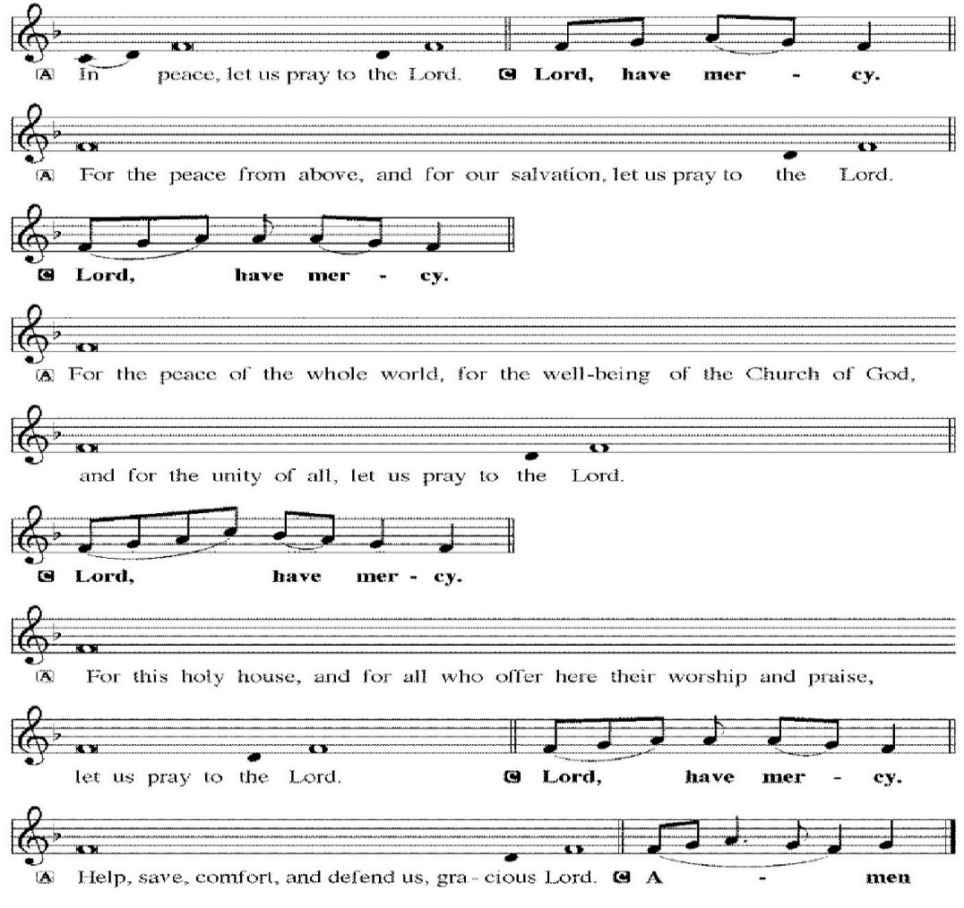

*Salutation 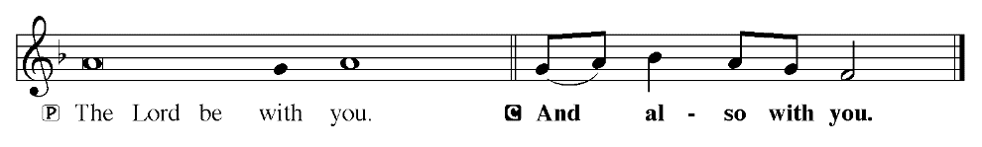
Prayer of the Day
P: Let us pray. O Lord God,
Almighty God, look favorably upon your family. Graciously rule our bodies lest we are enticed to love the world, and guard our spirits lest we fail to recognize your love. Grant this, we pray, through Jesus Christ, your Son, our Lord, who lives and reigns with you and the Holy Spirit, one God, now and forever.
C: Amen.

Children dismissed for children's church

First Reading: Ezekiel 37:1–14 (ESV)
The hand of the LORD was upon me, and he brought me out in the Spirit of the LORD and set me down in the middle of the valley; it was full of bones. ² And he led me around among them, and behold, there were very many on the surface of the valley, and behold, they were very dry. ³ And he said to me, “Son of man, can these bones live?” And I answered, “O Lord GOD, you know.” ⁴ Then he said to me, “Prophesy over these bones, and say to them, O dry bones, hear the word of the LORD. ⁵ Thus says the Lord GOD to these bones: Behold, I will cause breath to enter you, and you shall live. ⁶ And I will lay sinews upon you, and will cause flesh to come upon you, and cover you with skin, and put breath in you, and you shall live, and you shall know that I am the LORD.” ⁷ So I prophesied as I was commanded. And as I prophesied, there was a sound, and behold, a rattling, and the bones came together, bone to its bone. ⁸ And I looked, and behold, there were sinews on them, and flesh had come upon them, and skin had covered them. But there was no breath in them. ⁹ Then he said to me, “Prophesy to the breath; prophesy, son of man, and say to the breath, Thus says the Lord GOD: Come from the four winds, O breath, and breathe on these slain, that they may live.” ¹⁰ So I prophesied as he commanded me, and the breath came into them, and they lived and stood on their feet, an exceedingly great army. ¹¹ Then he said to me, “Son of man, these bones are the whole house of Israel. Behold, they say, ‘Our bones are dried up, and our hope is lost; we are indeed cut off.’ ¹² Therefore prophesy, and say to them, Thus says the Lord GOD: Behold, I will open your graves and raise you from your graves, O my people. And I will bring you into the land of Israel. ¹³ And you shall know that I am the LORD, when I open your graves, and raise you from your graves, O my people. ¹⁴ And I will put my Spirit within you, and you shall live, and I will place you in your own land. Then you shall know that I am the LORD; I have spoken, and I will do it, declares the LORD.”

The Word of God for the people of God!
C: Thanks be to God!

Psalm 130:1–8 (ESV) Read Responsively by Verse
Out of the depths I cry to you, O LORD!
² O Lord, hear my voice!
Let your ears be attentive
to the voice of my pleas for mercy!
³ If you, O LORD, should mark iniquities,
O Lord, who could stand?
⁴ But with you there is forgiveness,
that you may be feared.
⁵ I wait for the LORD, my soul waits,
and in his word I hope;
⁶ my soul waits for the Lord
more than watchmen for the morning,
more than watchmen for the morning.
⁷ O Israel, hope in the LORD!
For with the LORD there is steadfast love,
and with him is plentiful redemption.
⁸ And he will redeem Israel
from all his iniquities.

Second Reading: Romans 8:1–11 (ESV)
There is therefore now no condemnation for those who are in Christ Jesus. ² For the law of the Spirit of life has set you free in Christ Jesus from the law of sin and death. ³ For God has done what the law, weakened by the flesh, could not do. By sending his own Son in the likeness of sinful flesh and for sin, he condemned sin in the flesh, ⁴ in order that the righteous requirement of the law might be fulfilled in us, who walk not according to the flesh but according to the Spirit. ⁵ For those who live according to the flesh set their minds on the things of the flesh, but those who live according to the Spirit set their minds on the things of the Spirit. ⁶ For to set the mind on the flesh is death, but to set the mind on the Spirit is life and peace. ⁷ For the mind that is set on the flesh is hostile to God, for it does not submit to God’s law; indeed, it cannot. ⁸ Those who are in the flesh cannot please God. ⁹ You, however, are not in the flesh but in the Spirit, if in fact the Spirit of God dwells in you. Anyone who does not have the Spirit of Christ does not belong to him. ¹⁰ But if Christ is in you, although the body is dead because of sin, the Spirit is life because of righteousness. ¹¹ If the Spirit of him who raised Jesus from the dead dwells in you, he who raised Christ Jesus from the dead will also give life to your mortal bodies through his Spirit who dwells in you.

The Word of God for the people of God!
C: Thanks be to God!

*Lenten Gospel Acclamation

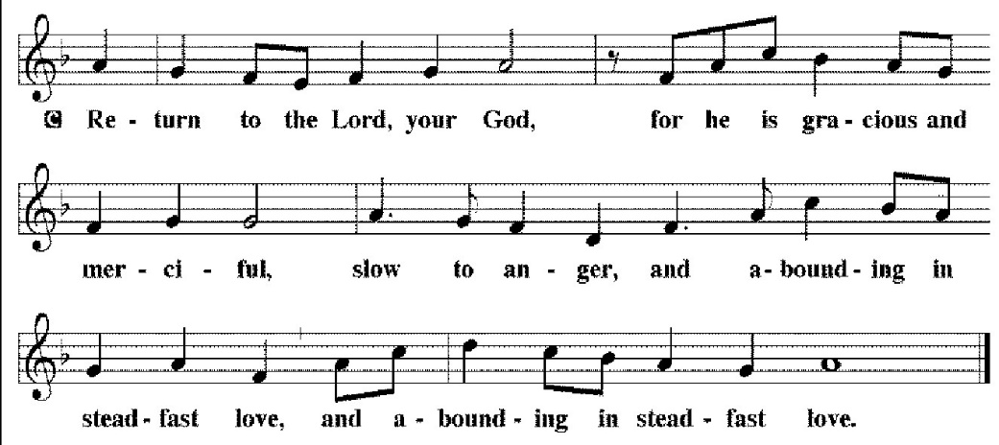

The Holy Gospel according to St. John, the 11th chapter.
C: Glory to you, O Lord.

The Holy Gospel: ST. JOHN 11: 1-53 (ESV)

Now a certain man was ill, Lazarus of Bethany, the village of Mary and her sister Martha. ² It was Mary who anointed the Lord with ointment and wiped his feet with her hair, whose brother Lazarus was ill. ³ So the sisters sent to him, saying, “Lord, he whom you love is ill.” ⁴ But when Jesus heard it he said, “This illness does not lead to death. It is for the glory of God, so that the Son of God may be glorified through it.” ⁵ Now Jesus loved Martha and her sister and Lazarus. ⁶ So, when he heard that Lazarus was ill, he stayed two days longer in the place where he was. ⁷ Then after this he said to the disciples, “Let us go to Judea again.” ⁸ The disciples said to him, “Rabbi, the Jews were just now seeking to stone you, and are you going there again?” ⁹ Jesus answered, “Are there not twelve hours in the day? If anyone walks in the day, he does not stumble, because he sees the light of this world. ¹⁰ But if anyone walks in the night, he stumbles, because the light is not in him.” ¹¹ After saying these things, he said to them, “Our friend Lazarus has fallen asleep, but I go to awaken him.” ¹² The disciples said to him, “Lord, if he has fallen asleep, he will recover.” ¹³ Now Jesus had spoken of his death, but they thought that he meant taking rest in sleep. ¹⁴ Then Jesus told them plainly, “Lazarus has died, ¹⁵ and for your sake I am glad that I was not there, so that you may believe. But let us go to him.” ¹⁶ So Thomas, called the Twin, said to his fellow disciples, “Let us also go, that we may die with him.”

¹⁷ Now when Jesus came, he found that Lazarus had already been in the tomb four days. ¹⁸ Bethany was near Jerusalem, about two miles off, ¹⁹ and many of the Jews had come to Martha and Mary to console them concerning their brother. ²⁰ So when Martha heard that Jesus was coming, she went and met him, but Mary remained seated in the house. ²¹ Martha said to Jesus, “Lord, if you had been here, my brother would not have died. ²² But even now I know that whatever you ask from God, God will give you.” ²³ Jesus said to her, “Your brother will rise again.” ²⁴ Martha said to him, “I know that he will rise again in the resurrection on the last day.” ²⁵ Jesus said to her, “I am the resurrection and the life. Whoever believes in me, though he die, yet shall he live, ²⁶ and everyone who lives and believes in me shall never die. Do you believe this?” ²⁷ She said to him, “Yes, Lord; I believe that you are the Christ, the Son of God, who is coming into the world.” ²⁸ When she had said this, she went and called her sister Mary, saying in private, “The Teacher is here and is calling for you.” ²⁹ And when she heard it, she rose quickly and went to him. ³⁰ Now Jesus had not yet come into the village, but was still in the place where Martha had met him. ³¹ When the Jews who were with her in the house, consoling her, saw Mary rise quickly and go out, they followed her, supposing that she was going to the tomb to weep there. ³² Now when Mary came to where Jesus was and saw him, she fell at his feet, saying to him, “Lord, if you had been here, my brother would not have died.” ³³ When Jesus saw her weeping, and the Jews who had come with her also weeping, he was deeply moved in his spirit and greatly troubled. ³⁴ And he said, “Where have you laid him?” They said to him, “Lord, come and see.” ³⁵ Jesus wept. ³⁶ So the Jews said, “See how he loved him!” ³⁷ But some of them said, “Could not he who opened the eyes of the blind man also have kept this man from dying?” ³⁸ Then Jesus, deeply moved again, came to the tomb. It was a cave, and a stone lay against it. ³⁹ Jesus said, “Take away the stone.” Martha, the sister of the dead man, said to him, “Lord, by this time there will be an odor, for he has been dead four days.” ⁴⁰ Jesus said to her, “Did I not tell you that if you believed you would see the glory of God?” ⁴¹ So they took away the stone. And Jesus lifted up his eyes and said, “Father, I thank you that you have heard me. ⁴² I knew that you always hear me, but I said this on account of the people standing around, that they may believe that you sent me.” ⁴³ When he had said these things, he cried out with a loud voice, “Lazarus, come out.” ⁴⁴ The man who had died came out, his hands and feet bound with linen strips, and his face wrapped with a cloth. Jesus said to them, “Unbind him, and let him go.” ⁴⁵ Many of the Jews therefore, who had come with Mary and had seen what he did, believed in him, ⁴⁶ but some of them went to the Pharisees and told them what Jesus had done. ⁴⁷ So the chief priests and the Pharisees gathered the council and said, “What are we to do? For this man performs many signs. ⁴⁸ If we let him go on like this, everyone will believe in him, and the Romans will come and take away both our place and our nation.” ⁴⁹ But one of them, Caiaphas, who was high priest that year, said to them, “You know nothing at all. ⁵⁰ Nor do you understand that it is better for you that one man should die for the people, not that the whole nation should perish.” ⁵¹ He did not say this of his own accord, but being high priest that year he prophesied that Jesus would die for the nation, ⁵² and not for the nation only, but also to gather into one the children of God who are scattered abroad. ⁵³ So from that day on they made plans to put him to death.

This is the Gospel of our Lord.
C: Praise to you, O Christ.

sermon Pastor Carl Haynes

*Sermon Hymn “What A Friend We Have In Jesus” LBW 439

*Apostles' Creed
C: I believe in God, the Father almighty,
creator of heaven and earth.
I believe in Jesus Christ, his only Son, our Lord.
He was conceived by the power of the Holy Spirit
and born of the virgin Mary.
He suffered under Pontius Pilate,
was crucified, died, and was buried.
He descended into hell.
On the third day he rose again.
He ascended into heaven,
and is seated at the right hand of the Father.
He will come again to judge the living and the dead.
I believe in the Holy Spirit,
the holy catholic Church,
the communion of saints,
the forgiveness of sins,
the resurrection of the body,
and the life everlasting.
Amen
Receiving of our Tithes and Offerings

*The Offertory
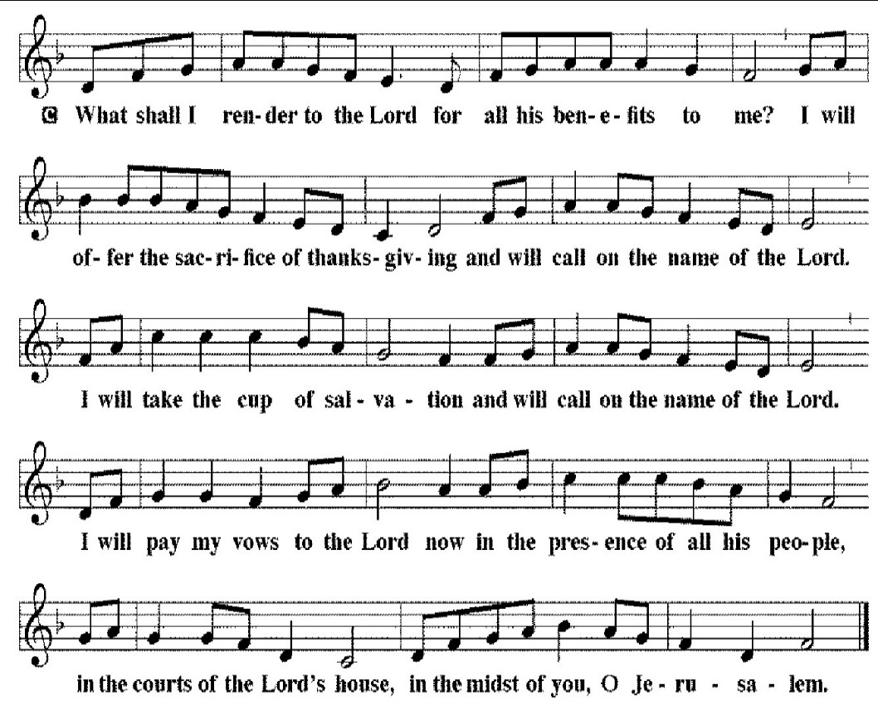
*Prayer of the Church

*The Lord's Prayer
C: Our Father, who art in heaven, hallowed be thy name,
thy kingdom come,
thy will be done,
on earth as it is in heaven.
Give us this day our daily bread;
and forgive us our trespasses,
as we forgive those who trespass against us;
and lead us not into temptation,
but deliver us from evil.
For thine is the kingdom, and the power, and the glory,
forever and ever. Amen
*Benediction
P: The Lord bless you and keep you.
The Lord make his face shine on you and be gracious to you.
The Lord look upon you with favor, and give you peace.
C: Amen

*Sending Hymn “Alas! And Did My Savior Bleed” LBW 98
*Dismissal
P: Go in peace. Serve the Lord.
C: Thanks be to God.

*Postlude
Used by permission of Augsburg Fortress under license # SB127756.

Fifth Sunday in Lent
Today we are reminded of the blessed promise that God brings life out of death. Whether it is breath to dead, brittle, dry bones or hope for those stuck in sorrow and despair, new life emerges by God’s mighty hand. Jesus demonstrates this power to those around him as he raises Lazarus from the dead after four long days. This miracle foreshadows his own impending death and resurrection.



Sunday March 29th Palm/Passion Sunday 10:00 AM
Thursday April 2 Maundy Thursday Service 7:00 PM
Friday April 3 Good Friday Service 7:00 PM
Sunday April 5 Easter Sunrise Service 7:00 AM
Sunday April 5 Easter Morning Breakfast 7:30 AM
Sunday April 5 Easter Holy Communion 9:00 AM
NO SUNDAY SCHOOL CLASSES

The Altar Flowers are given to the Glory of God and in honor of Weston David Drye's birth and his family, Matt, Kristi, and Walker. By his Grandparents Rusty & Rhonda Drye, David & Gail Leonard.

Congratulations Matt, Kristi (and big brother Walker) on the birth of their son Weston David Drye. Born March 16th at 10:24am, 7lb 6oz, 19 3/4inches. Grandparents: Rusty and Rhonda Drye, David, and Gail Leonard

We would like to thank Pastor Haynes for leading our service today.

APRIL newsletter articles are due TODAY.

The second and last New Member Class with Pastor Haynes will be Sunday, 3.29.26 during the Sunday School Time frame in the Parlor. Bring your Bible.

Annual Easter Egg Hunt Saturday March 29, Palm Sunday, at 2pm. Children ages 2-10 are welcome to join us in 2 eggs hunts and cookie decorating in between the hunts. Invite your neighbors and friends. CSI will NOT meet today.

Easter Lilies and Geraniums will be placed in the sanctuary on Easter Sunday, April 5th. If you would like to order, the cost is $15.00 for Lilies and $15.00 for Geraniums. Orders are due TODAY.

There will be a Community meeting at Rimer Volunteer Fire Dept on March 30, 2026 at 7:00 pm in reference to the new fire truck.

Thrivent Choice Dollars are available to anyone that has life insurance or annuities with Thrivent. Our church is one of the organizations you may direct your Dollars to. The last day you can enter this online is March 31, 2026.

The PBnJ Youth Group is making Easter bags for the Life Center. We need of individual Kleenex and pastel colored “lunch” paper bags. Thank you
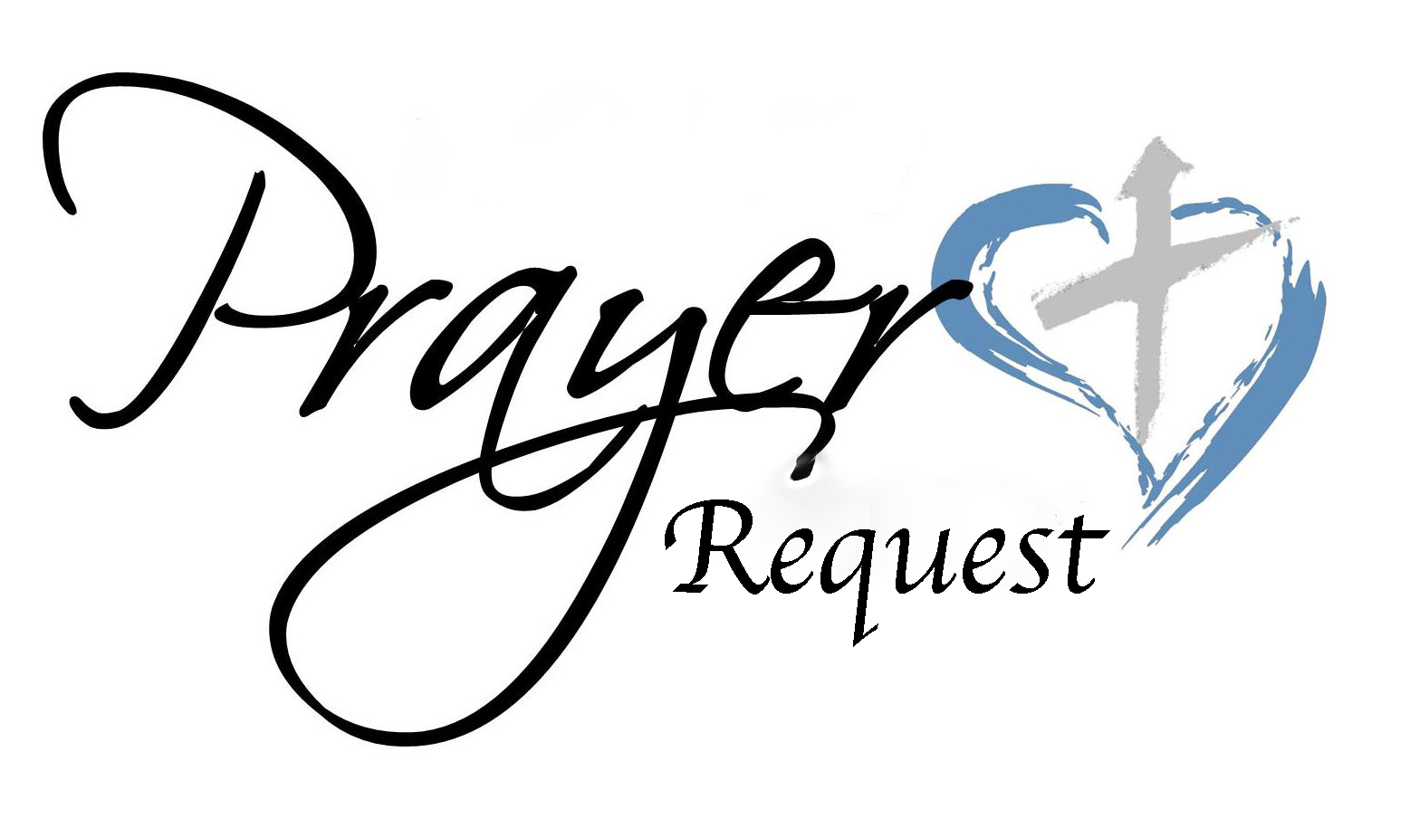
March 22, 2026
We ask that you always have an individual’s permission before
requesting their name be added to our Prayer List.
Please send prayer list request additions or changes
to prayercclc@gmail.com by Tuesday 5 PM.

First of all, then, I urge that supplications, prayers, intercessions,
and thanksgivings be made for all people… 1Timothy 2:1

In the Fellowship of Cross of Christ
Melvin Bost (Back surgery on March 23rd at Atrium Northeast Hospital);
Jane Faggart; Pastor Carl Haynes (Surgery was successful, and he is recovering at home)

Call Process prayer requests: 1) Cross of Christ Church; 2) Call Committee; 3) Prospective pastors see our profile/video and consider a call here.

Shut-Ins
Bob and Joann Barrier; Brenda Barrier; Norman Goodman;
Nell Hatley; John Trull.

Friends of Cross of Christ
Roddy Ballard; LeaAnn Buckwell; Addie Drye; April Funderburke;
Lee Gorforth; Candice Horton; Cynthia Horton; Alicia McQueen;
Susan Starling; Daniel Pless; Jacob Rodgers; Nick Smith;
Melanie Thrift; Max Vanderburg; Bob Wilson; Candace Yates

Carolina Mission Region Seminarians: Melanie Corn, Robert Dernbach, Lucas Safrit

Serving in the Military
Eaven Allison (Fairbanks, Alaska)

General Prayer Concerns:
Ongoing Iran war impacts
Praise List:
· Matt & Kristi Drye – Prayers were appreciated prior to Weston’s birth. Both Kristi and Weston are doing very good.

· Ed Duncan – Prayers have been appreciated and the tumor is shrinking.

** Please remember our shut-ins with a visit, phone call,
cards, or email along with your prayers
Today – March 22, 2026
Sunday Church School 9:00 AM
Family Worship Service 10:00 AM

This Week
MON: 7 – 8:30 PM Soldiers of the Cross of Christ Practice

NEXT SUNDAY
9:00 AM Sunday Church School Classes
10:00 AM Family Worship Service

Next Sunday's Readings
Palm Sunday
Isaiah 50: 4-9a
Psalm 118: 19-26
Philippians 2: 5-11
St. Matthew 26: 1-27: 66

www.crossofchristlutheranchurch.org http://www.facebook.com/CrossofChristLutheranChurchConcord
ClericalTeam@Gmail.com
prayercclc@gmail.com

