
4500 Rimer Rd, Concord, NC 28025
Church 704-782-8483

A NALC Congregation



Welcome to worship at Cross of Christ!
In the Cross of Christ I glory

Fourth Sunday After Pentecost
June 21, 2026
(* Please stand as you are able)

Prelude

Our Accompanist Mrs. Yvonne Yost

Greetings and Announcements

*Brief Order For Confession and Forgiveness

In the name of the Father, and of the Son, and of the Holy Spirit.
Amen

P: Almighty God, to whom all hearts are open, all desires known, and from whom no secrets are hid: Cleanse the thoughts of our hearts by the inspiration of your Holy Spirit, that we may perfectly love you and worthily magnify your holy name, through Jesus Christ our Lord.
C: Amen

P: If we say we have no sin, we deceive ourselves, and the truth is not in us. But if we confess our sins, God who is faithful and just will forgive our sins and cleanse us from all unrighteousness.

Silence for reflection and self-examination.

P: Most merciful God,
C: we confess that we are in bondage to sin and cannot free ourselves. We have sinned against you in thought, word, and deed, by what we have done and by what we have left undone. We have not loved you with our whole heart; we have not loved our neighbors as ourselves. For the sake of your Son, Jesus Christ, have mercy on us. Forgive us, renew us, and lead us, so that we may delight in your will and walk in your ways, to the glory of your holy name. Amen

P: Almighty God, in his mercy, has given his Son to die for us and, for his sake, forgives us all our sins. As a called and ordained minister of the Church of Christ, and by his authority, I therefore declare to you the entire forgiveness of all your sins, in the name of the Father, and of the Son, and of the Holy Spirit.
C: Amen

* Opening Hymn “Faith Of Our Fathers” LBW 500

*Apostolic Greeting
The grace of our Lord Jesus Christ, the love of God, and the communion of the Holy Spirit be with you all.
And also with you.

*Hymn of Praise: “Glory to God”

*Salutation

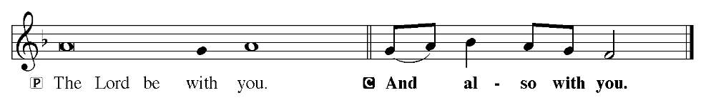

Prayer of the Day
P: For those who love you, O God, you have chosen and prepared what no eye has seen nor ear heard. Pour into our hearts a loving affection for you, that we may choose you in and above all things. For only then shall we have what you promise, which far exceeds all we can desire; through Jesus Christ, your Son, our Lord. He lives and reigns with you and the Holy Spirit, one God, now and forever.
C: Amen

Children dismissed for children's church

First Reading: Jeremiah 20:7-13 (ESV)
⁷ O Lord, you have deceived me, and I was deceived; you are stronger than I, and you have prevailed. I have become a laughingstock all the day; everyone mocks me. ⁸ For whenever I speak, I cry out, I shout, “Violence and destruction!” For the word of the Lord has become for me a reproach and derision all day long. ⁹ If I say, “I will not mention him, or speak any more in his name,” there is in my heart as it were a burning fire shut up in my bones, and I am weary with holding it in,
and I cannot. ¹⁰ For I hear many whispering. Terror is on every side!
“Denounce him! Let us denounce him!” say all my close friends,
watching for my fall. “Perhaps he will be deceived; then we can overcome him and take our revenge on him.” ¹¹ But the Lord is with me as a dread warrior; therefore my persecutors will stumble; they will not overcome me. They will be greatly shamed, for they will not succeed.
Their eternal dishonor will never be forgotten. ¹² O Lord of hosts, who tests the righteous, who sees the heart and the mind, let me see your vengeance upon them, for to you have I committed my cause. ¹³ Sing to the Lord; praise the Lord! For he has delivered the life of the needy
from the hand of evildoers.

The Word of God for the people of God!
Thanks be to God!

Psalm 91:1-10, 11-16 (ESV) Read Responsively by Verse
He who dwells in the shelter of the Most High
will abide in the shadow of the Almighty.
² I will say to the Lord, “My refuge and my fortress,
my God, in whom I trust.”
³ For he will deliver you from the snare of the fowler
and from the deadly pestilence.
⁴ He will cover you with his pinions,
and under his wings you will find refuge;
his faithfulness is a shield and buckler.
⁵ You will not fear the terror of the night,
nor the arrow that flies by day,
⁶ nor the pestilence that stalks in darkness,
nor the destruction that wastes at noonday.
⁷ A thousand may fall at your side,
ten thousand at your right hand,
but it will not come near you.
⁸ You will only look with your eyes
and see the recompense of the wicked.
⁹ Because you have made the Lord your dwelling place—
the Most High, who is my refuge—
¹⁰ no evil shall be allowed to befall you,
no plague come near your tent.
¹¹ For he will command his angels concerning you
to guard you in all your ways.
¹² On their hands they will bear you up,
lest you strike your foot against a stone.
¹³ You will tread on the lion and the adder;
the young lion and the serpent you will trample underfoot.
¹⁴ “Because he holds fast to me in love, I will deliver him;
I will protect him, because he knows my name.
¹⁵ When he calls to me, I will answer him;
I will be with him in trouble;
I will rescue him and honor him.
¹⁶ With long life I will satisfy him
and show him my salvation.”

Second Reading: Romans 6:12-23 (ESV)
³ Blessed be the God and Father of our Lord Jesus Christ, who has blessed us in Christ with every spiritual blessing in the heavenly places, ⁴ even as he chose us in him before the foundation of the world, that we should be holy and blameless before him. In love ⁵ he predestined us for adoption to himself as sons through Jesus Christ, according to the purpose of his will, ⁶ to the praise of his glorious grace, with which he has blessed us in the Beloved. ⁷ In him we have redemption through his blood, the forgiveness of our trespasses, according to the riches of his grace, ⁸ which he lavished upon us, in all wisdom and insight ⁹ making known to us the mystery of his will, according to his purpose, which he set forth in Christ ¹⁰ as a plan for the fullness of time, to unite all things in him, things in heaven and things on earth. ¹¹ In him we have obtained an inheritance, having been predestined according to the purpose of him who works all things according to the counsel of his will, ¹² so that we who were the first to hope in Christ might be to the praise of his glory. ¹³ In him you also, when you heard the word of truth, the gospel of your salvation, and believed in him, were sealed with the promised Holy Spirit, 14 who is the guarantee of our inheritance until we acquire possession of it, to the praise of his glory.

The Word of God for the people of God!
Thanks be to God!

*Gospel Acclamation
The Holy Gospel according to St. Matthew, the 10th chapter.

*The Holy Gospel: St. Matthew 10:5a, 21-33 (ESV)
⁵ These twelve Jesus sent out, instructing them, “Go nowhere among the Gentiles and enter no town of the Samaritans, ²¹ Brother will deliver brother over to death, and the father his child, and children will rise against parents and have them put to death, ²² and you will be hated by all for my name's sake. But the one who endures to the end will be saved. ²³ When they persecute you in one town, flee to the next, for truly, I say to you, you will not have gone through all the towns of Israel before the Son of Man comes. ²⁴ “A disciple is not above his teacher, nor a servant above his master. ²⁵ It is enough for the disciple to be like his teacher, and the servant like his master. If they have called the master of the house Beelzebul, how much more will they malign those of his household. ²⁶ “So have no fear of them, for nothing is covered that will not be revealed, or hidden that will not be known. ²⁷ What I tell you in the dark, say in the light, and what you hear whispered, proclaim on the housetops. ²⁸ And do not fear those who kill the body but cannot kill the soul. Rather fear him who can destroy both soul and body in hell. ²⁹ Are not two sparrows sold for a penny? And not one of them will fall to the ground apart from your Father. ³⁰ But even the hairs of your head are all numbered. ³¹ Fear not, therefore; you are of more value than many sparrows. ³² So everyone who acknowledges me before men, I also will acknowledge before my Father who is in heaven, ³³ but whoever denies me before men, I also will deny before my Father who is in heaven.

This is Gospel of our Lord
Praise to you, O Christ.

Sermon Pastor George Rhyne

*Sermon Hymn “This Little Light Of Mine”

This Little Light Of Mine

This little light of mine, I’m gonna let it shine (repeat 3 times).
Let it shine, let it shine, let it shine.

Hide it under a bushel, no! I’m gonna let it shine (repeat 3 times).
Let it shine, let it shine, let it shine.

Don’t let Satan blow it out, I’m gonna let it shine (repeat 3 times).
Let it shine, let it shine, let it shine.

Shine around the neighbourhood, I’m gonna let it shine (repeat 3 times).
Let it shine, let it shine, let it shine.

Repeat the first verse.

*The Sacrament of Holy Baptism LBW 121-125
Ella Rose Miller, granddaughter of Richard and Betty Archer;
Jasper Axel Tidd, son of Kaasi Leonard.

Receiving of our Tithes and Offerings
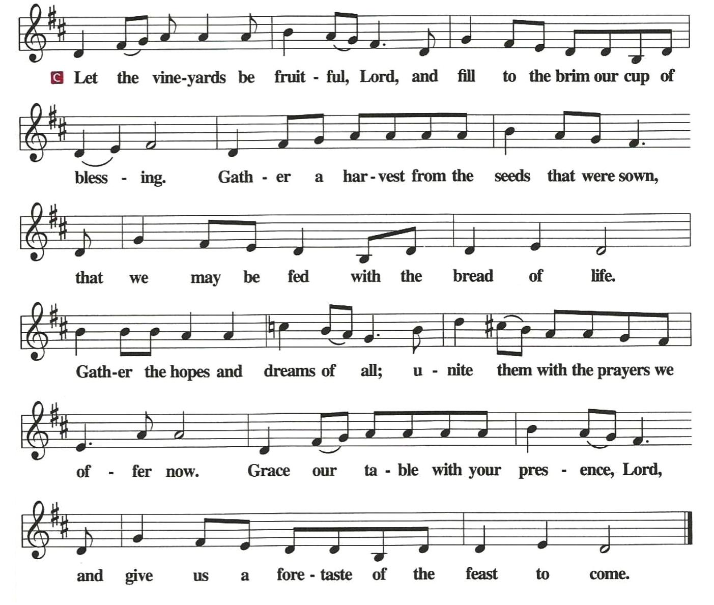
*The Offertory
*Prayer of the Church

*The Lord's Prayer
Our Father, who art in heaven, hallowed be thy name,
thy kingdom come,
thy will be done,
on earth as it is in heaven.
Give us this day our daily bread;
and forgive us our trespasses,
as we forgive those who trespass against us;
and lead us not into temptation,
but deliver us from evil.
For thine is the kingdom, and the power, and the glory,
forever and ever. Amen

*Benediction
The Lord bless you and keep you.
The Lord make his face shine on you and be gracious to you.
The Lord look upon you with favor and give you peace.
Amen

*Sending Hymn “God Of Our Fathers" WOV 567

*Dismissal
Go in peace. Serve the Lord.
Thanks be to God.

*Postlude (* Please stand as you are able)

Used by permission of Augsburg Fortress under license # SB127756.

The Altar Flowers are given to the Glory of God and in honor of Father’s Day by Larry Barbee.

We would like to thank Pastor Rhyne for leading our service today.

Pedestal flowers are given in celebration for David and Gail Leonard’s 40th Wedding Anniversary from their children and grandchildren.

We welcome two new members today by the Sacrament of Holy Baptism.
Ella Rose Miller, granddaughter of Richard and Betty Archer and
Jasper Axel Tidd, son of Kaasi Leonard.

July Newsletter Articles are due TODAY!

The Call Committee appreciates your participation in the survey response for the updating of the Church Profile. Please return your responses in the box located in the mailroom before the end of service on 6/28/26. If you have any questions, please reach out to a Call Committee member.

Coltrane Life Center is having a bake sale July 2, 8am – until. If you can donate or purchase baked goods, we’d appreciate it. Proceeds benefit older adults and their families who need adult day health services. Thank you for your support. Please see Susan Caudle for donation information.

The PBnJ Youth group will be going to the Life Center on July 2nd at 10:30 to play BINGO.

VBS – 2026 July 6-10, 6:00-8:30 Ages 2 - 5th Grade
If you would like to help, please contact Meredith Harrison.
Below is a link for snack items that are needed for VBS. All items need to be to Meredith by July 1, 2026. Thank you for your help.
https://www.signupgenius.com/go/10C0445AFAC2CAAFDC34-64296670-vbs2026

June 21, 2026
We ask that you always have an individual’s permission before
requesting their name be added to our Prayer List.
Please send prayer list request additions or changes to
prayercclc@gmail.com by Tuesday 5PM.

First of all, then, I urge that supplications, prayers, intercessions, and thanksgivings be made for all people… 1Timothy 2:1

In the Fellowship of Cross of Christ
Melvin Bost; Jasper Tidd; Rand Yost (Trinity Oaks – room C2)

Call Process prayer requests: 1) Cross of Christ Church; 2) Call Committee; 3) Prospective pastors see our profile/video and consider a call here.

Shut-Ins
Bob & Joann Barrier; Brenda Barrier; Norman Goodman; Nell Hatley; John Trull.

Friends of Cross of Christ
April Funderburke; Lee Gorforth; Candice Horton; Cynthia Horton; Alicia McQueen; Eric Starling; Susan Starling; Ruthie O’Brien;
Daniel Pless; Jacob Rodgers; Nick Smith; Bob Wilson; Candace Yates

Serving in the Military
Eaven Allison (Fairbanks, Alaska)

General Prayer Concerns:
· Ongoing Iran war impacts

· Prayers for rain – we are thankful for recent rain showers. Most of this area needs significantly more rain showers, both in amount and frequency. Lack of moisture is greatly reducing pasture and hay yields, forcing farmers to sell cattle for lack of feed. Please pray for timely and abundant rain showers.

** Please remember our shut-ins with a visit, phone call, card, or email along with your prayers

Today June 21, 2026

Sunday Church School 9:00 AM
Family Worship Service 10:00 AM

This Week

MON: 7-8:30 Soldiers of Cross of Christ Practice

NEXT SUNDAY
9:00 AM Sunday Church School Classes
10:00 AM Family Worship Service

Next Sunday's Readings

Fifth Sunday after Pentecost
Jeremiah 28:5-9
Psalm 119:153-160
Romans 7:1-13
St. Matthew 10:34-42

www.crossofchristlutheranchurch.org http://www.facebook.com/CrossofChristLutheranChurchConcord
ClericalTeam@Gmail.com

