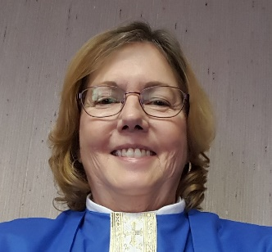
Autobiographical information for Pastor Marty Ramey
I was born 3rd of 7 children to Harlan Ivan and Mary Ballard Burnett in the small Rio Grande Valley town of Raymondville, Texas. My father worked in construction, mother was a registered nurse. She served as County Health Nurse for our small county for over 15 years. Her dedication to serving the migrant community was formative for my faith. We attended the Presbyterian Church every Sunday during my childhood, come rain or shine.
Following high school, I attended Rice University for 2 years. Several years later, I completed my Bachelor of Science degree in Microbiology at Purdue University. I worked in research labs in Winston-Salem and Research Triangle Park near Raleigh for 10 years. My first husband and I adopted our son Mike in 1985 in Winston-Salem and our daughter Brynn in 1989 from Peru. Following our divorce, I received my Master of Divinity degree from Lutheran Theological Southern Seminary in 1995.
I was ordained in 1998 and served my first call at Salem Lutheran Church in Lincolnton, NC. In 2000, I began a one-year resident chaplaincy program in Clinical Pastoral Education at Carolinas Healthcare System. Upon completion, I served as chaplain at the Lutheran nursing homes in Hickory and later at Hospice of Lincoln County. In 2001, I completed training as an interim pastor at the Centers for Congregational Health, Winston-Salem, North Carolina.
Returning to congregational ministry, I served as full-time pastor in two congregations in the Gaston County area. In 1996, I remarried. The 24 years of my marriage to Marion were the greatest blessing I have experienced in my life; he and I were inseparable. We traveled throughout the United States and I have wonderful memories of the places we visited.
In 2016, I began serving as an intentional interim minister. I have subsequently served in ten congregations in transition between pastors to meet the spiritual care needs of the congregation and to assist them in the call process. Marion’s health declined over several years, and in 2018 I stayed home to care for him. Marion died from complications of diabetes in 2019.
I believe that God has given me the skills, the training, and the experience for interim ministry. My decision to answer God’s call back into serving him in the best way I can is founded in my belief that God’s plans are always for the best. “…we know that for those who love God all things work together for good, for those who are called according to his purpose.” (Romans 8:28)

