

A NALC Congregation

4500 Rimer Rd, Concord, NC 28025
Church 704-782-8483



Welcome to worship at Cross of Christ!
In the Cross of Christ I glory

Third Sunday In Lent
March 8, 2026

(* Please stand as you are able)

Prelude Our Accompanist Mrs. Yvonne Yost

Greetings and Announcements

*Brief Order For Confession and Forgiveness

P: In the name of the Father, and of the Son, and of the Holy Spirit.
C: Amen

P: Almighty God, to whom all hearts are open, all desires known, and from whom no secrets are hid: Cleanse the thoughts of our hearts by the inspiration of your Holy Spirit, that we may perfectly love you and worthily magnify your holy name, through Jesus Christ our Lord.
C: Amen

P: If we say we have no sin, we deceive ourselves, and the truth is not in us. But if we confess our sins, God who is faithful and just will forgive our sins and cleanse us from all unrighteousness.

Silence for reflection and self-examination.

P: Most merciful God,
C: we confess that we are in bondage to sin and cannot free ourselves. We have sinned against you in thought, word, and deed, by what we have done and by what we have left undone. We have not loved you with our whole heart; we have not loved our neighbors as ourselves. For the sake of your Son, Jesus Christ, have mercy on us. Forgive us, renew us, and lead us, so that we may delight in your will and walk in your ways, to the glory of your holy name.
Amen

P: In the mercy of Almighty God, Jesus Christ was given to die for you, and for His sake God forgives you all your sins. To those who believe in Jesus Christ he gives the power to become the children of God and bestows on them the Holy Spirit.
C: Amen

* Opening Hymn “Great Is Thy Faithfulness” WOV 771

Apostolic Greeting
P: The grace of our Lord Jesus Christ, the love of God, and the communion of the Holy Spirit be with you all.
C: And also with you.

*Lenten kyrie
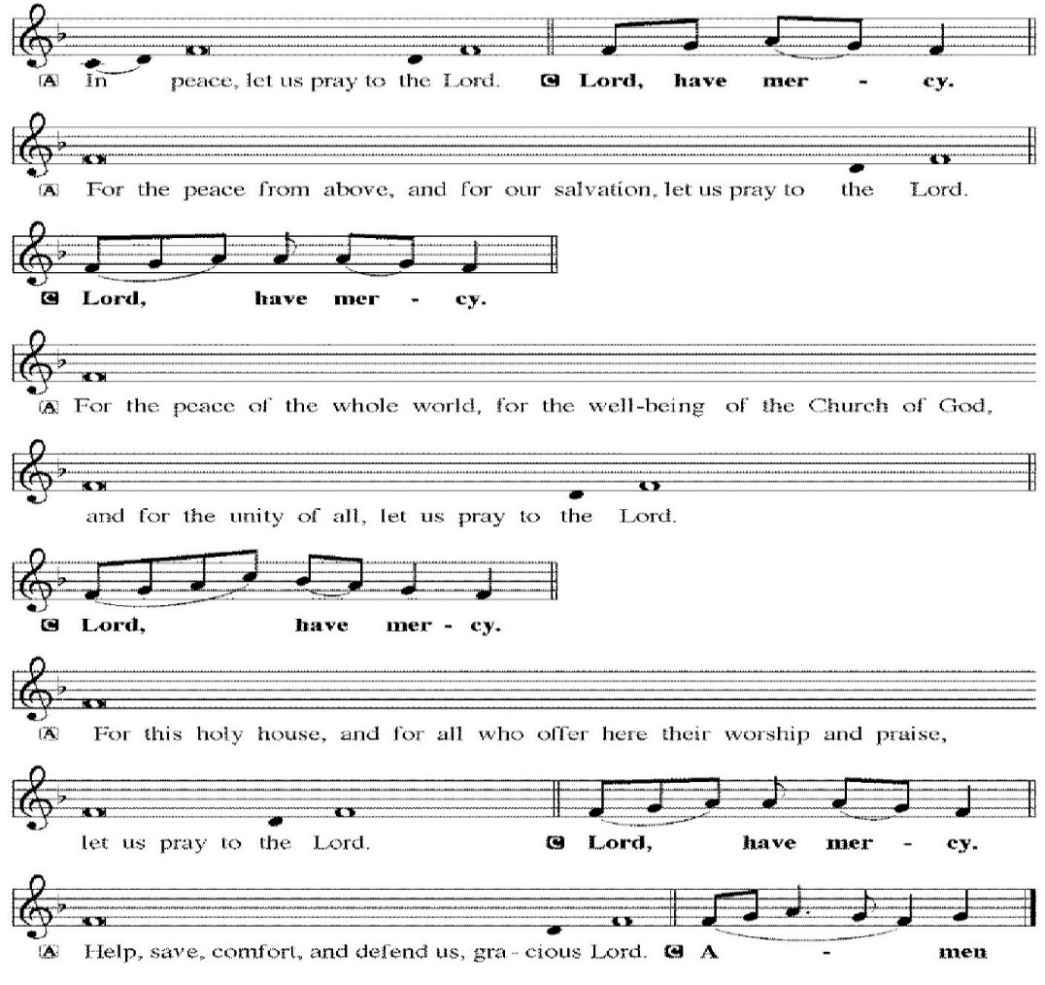

*Salutation & Prayer of the Day
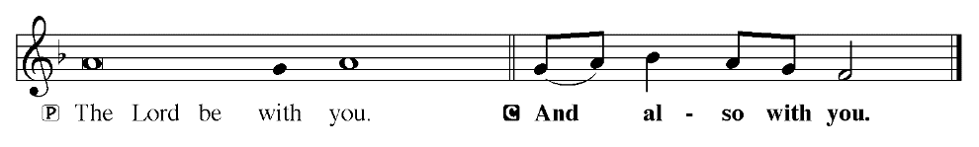
Prayer of the Day
P: Let us pray.
Almighty God, consider the worthy desires of your humble servants. Reach out to defend us from evil by the word and work of your majestic right hand. Grant this, we pray, through the same Jesus Christ, your Son, our Lord, who lives and reigns with you and the Holy Spirit, one God, now and forever.
C: Amen.

Children dismissed for children's church

First Reading: Exodus 17: 1-7 (ESV)
¹All the congregation of the people of Israel moved on from the wilderness of Sin by stages, according to the commandment of the Lord, and camped at Rephidim, but there was no water for the people to drink. ² Therefore the people quarreled with Moses and said, “Give us water to drink.” And Moses said to them, “Why do you quarrel with me? Why do you test the Lord?” ³ But the people thirsted there for water, and the people grumbled against Moses and said, “Why did you bring us up out of Egypt, to kill us and our children and our livestock with thirst?” ⁴ So Moses cried to the Lord, “What shall I do with this people? They are almost ready to stone me.” ⁵ And the Lord said to Moses, “Pass on before the people, taking with you some of the elders of Israel, and take in your hand the staff with which you struck the Nile, and go. ⁶ Behold, I will stand before you there on the rock at Horeb, and you shall strike the rock, and water shall come out of it, and the people will drink.” And Moses did so, in the sight of the elders of Israel. ⁷ And he called the name of the place Massah and Meribah, because of the quarreling of the people of Israel, and because they tested the Lord by saying, “Is the Lord among us or not?”

The Word of God for the people of God!

Thanks be to God!

Psalm 95: 1-9 Read Responsively by Verse
Oh come, let us sing to the Lord;
let us make a joyful noise to the rock of our salvation!
² Let us come into his presence with thanksgiving;
let us make a joyful noise to him with songs of praise!
³ For the Lord is a great God,
and a great King above all gods.
⁴ In his hand are the depths of the earth;
the heights of the mountains are his also.
⁵ The sea is his, for he made it,
and his hands formed the dry land.
⁶ Oh come, let us worship and bow down;
let us kneel before the Lord, our Maker!
⁷ For he is our God,
and we are the people of his pasture,
and the sheep of his hand.
Today, if you hear his voice,
⁸ do not harden your hearts, as at Meribah,
as on the day at Massah in the wilderness,
⁹ when your fathers put me to the test
and put me to the proof, though they had seen my work.

Second Reading: romans 5: 1-8 (ESV)
¹ Therefore, since we have been justified by faith, we have peace with God through our Lord Jesus Christ. ² Through him we have also obtained access by faith into this grace in which we stand, and we rejoice in hope of the glory of God. ³ Not only that, but we rejoice in our sufferings, knowing that suffering produces endurance, ⁴ and endurance produces character, and character produces hope, ⁵ and hope does not put us to shame, because God's love has been poured into our hearts through the Holy Spirit who has been given to us. ⁶ For while we were still weak, at the right time Christ died for the ungodly. ⁷ For one will scarcely die for a righteous person—though perhaps for a good person one would dare even to die— ⁸ but God shows his love for us in that while we were still sinners, Christ died for us.

The Word of God for the people of God!
Thanks be to God!

*Lenten Gospel Acclamation

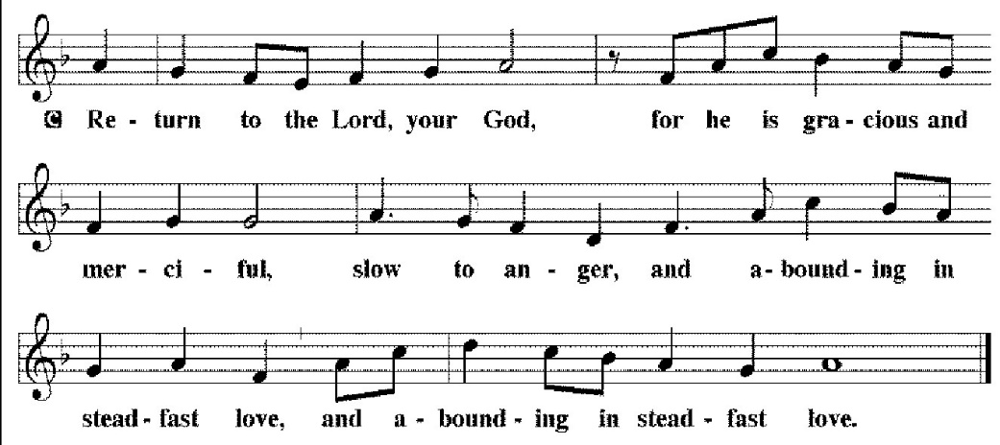

The Holy Gospel according to St. John, the 4th chapter.
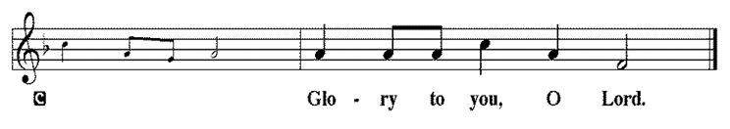

The Holy Gospel: ST. John 4: 5-30, 39-42 (ESV)

⁵ So he came to a town of Samaria called Sychar, near the field that Jacob had given to his son Joseph. ⁶ Jacob's well was there; so Jesus, wearied as he was from his journey, was sitting beside the well. It was about the sixth hour. ⁷ A woman from Samaria came to draw water. Jesus said to her, “Give me a drink.” ⁸ (For his disciples had gone away into the city to buy food.) ⁹ The Samaritan woman said to him, “How is it that you, a Jew, ask for a drink from me, a woman of Samaria?” (For Jews have no dealings with Samaritans.) ¹⁰ Jesus answered her, “If you knew the gift of God, and who it is that is saying to you, ‘Give me a drink,’ you would have asked him, and he would have given you living water.” ¹¹ The woman said to him, “Sir, you have nothing to draw water with, and the well is deep. Where do you get that living water? ¹² Are you greater than our father Jacob? He gave us the well and drank from it himself, as did his sons and his livestock.” ¹³ Jesus said to her, “Everyone who drinks of this water will be thirsty again, ¹⁴ but whoever drinks of the water that I will give him will never be thirsty again. The water that I will give him will become in him a spring of water welling up to eternal life.” ¹⁵ The woman said to him, “Sir, give me this water, so that I will not be thirsty or have to come here to draw water.” ¹⁶ Jesus said to her, “Go, call your husband, and come here.” ¹⁷ The woman answered him, “I have no husband.” Jesus said to her, “You are right in saying, ‘I have no husband;’ ¹⁸ for you have had five husbands, and the one you now have is not your husband. What you have said is true.” ¹⁹ The woman said to him, “Sir, I perceive that you are a prophet. ²⁰ Our fathers worshiped on this mountain, but you say that in Jerusalem is the place where people ought to worship.” ²¹ Jesus said to her, “Woman, believe me, the hour is coming when neither on this mountain nor in Jerusalem will you worship the Father. ²² You worship what you do not know; we worship what we know, for salvation is from the Jews. ²³ But the hour is coming, and is now here, when the true worshipers will worship the Father in spirit and truth, for the Father is seeking such people to worship him. ²⁴ God is spirit, and those who worship him must worship in spirit and truth.” ²⁵ The woman said to him, “I know that Messiah is coming (he who is called Christ). When he comes, he will tell us all things.” ²⁶ Jesus said to her, “I who speak to you am he.” ²⁷ Just then his disciples came back. They marveled that he was talking with a woman, but no one said, “What do you seek?” or, “Why are you talking with her?” ²⁸ So the woman left her water jar and went away into town and said to the people, ²⁹ “Come, see a man who told me all that I ever did. Can this be the Christ?” ³⁰ They went out of the town and were coming to him. ³⁹ Many Samaritans from that town believed in him because of the woman's testimony, “He told me all that I ever did.” ⁴⁰ So when the Samaritans came to him, they asked him to stay with them, and he stayed there two days. ⁴¹ And many more believed because of his word. ⁴² They said to the woman, “It is no longer because of what you said that we believe, for we have heard for ourselves, and we know that this is indeed the Savior of the world.”

This is Gospel of our Lord.
sermon Larry Barbee

*Sermon Hymn “My Hope Is Built” LBW 293
*Apostles' Creed
C: I believe in God, the Father almighty,
creator of heaven and earth.
I believe in Jesus Christ, his only Son, our Lord.
He was conceived by the power of the Holy Spirit
and born of the virgin Mary.
He suffered under Pontius Pilate,
was crucified, died, and was buried.
He descended into hell.
On the third day he rose again.
He ascended into heaven,
and is seated at the right hand of the Father.
He will come again to judge the living and the dead.
I believe in the Holy Spirit,
the holy catholic Church,
the communion of saints,
the forgiveness of sins,
the resurrection of the body,
and the life everlasting.
Amen

Receiving of our Tithes and Offerings

*The Offertory
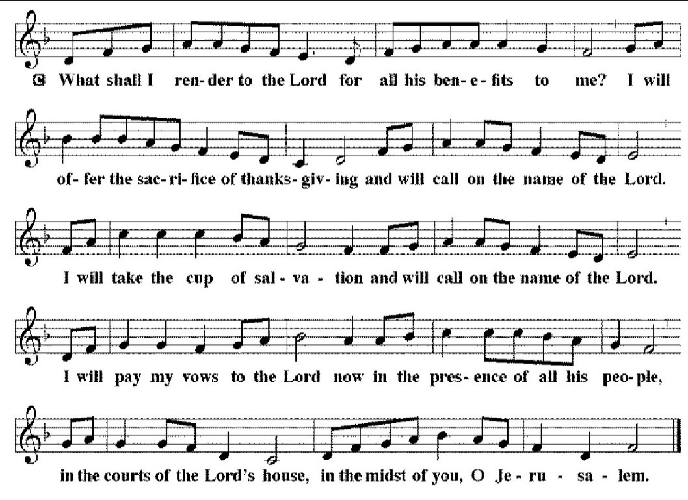
*Prayer of the Church

*The Lord's Prayer
C: Our Father, who art in heaven, hallowed be thy name,
thy kingdom come,
thy will be done,
on earth as it is in heaven.
Give us this day our daily bread;
and forgive us our trespasses,
as we forgive those who trespass against us;
and lead us not into temptation,
but deliver us from evil.
For thine is the kingdom, and the power, and the glory,
forever and ever. Amen

*Benediction
P: The Lord bless you and keep you.
The Lord make his face shine on you and be gracious to you.
The Lord look upon you with favor, and give you peace.
C: Amen

*Sending Hymn “In The Cross Of Christ I Glory” LBW 104
*Dismissal
P: Go in peace. Serve the Lord.
C: Thanks be to God.

*Postlude
Used by permission of Augsburg Fortress under license # SB127756.

First Sunday in Lent
This Sunday’s Gospel marks the beginning of Jesus’ public ministry as the Spirit pronounces him “Son of God” and drives him into the wilderness to be tempted by Satan. We, too, in our baptism, are pronounced children of God, which means we will face similar trials and temptations as our Lord did. The good news for us is that we will never be alone in our trials; Christ goes before us and remains with us.

The Altar Flowers are given to the Glory of God and in Memory of Terry & Mary Ann Sifford by John, Meredith, Marianna, Emma, & Justin

The PBnJ Youth Group will meet next Sunday, March 15th at 3:30. All Kindergarten - Fifth Graders are invited to attend.

The CSI Youth Group will meet next Sunday, March 15th at 3:30.

New Member Class with Pastor Haynes will be Sunday 3.22.26 and 3.29.26 during the Sunday School time 9:00 to 9:45 am in the parlor. Anyone interested in joining, please attend these meetings. Bring your Bible.

Easter Lilies and Geraniums will be placed in the sanctuary on Easter Sunday, April 5th. If you would like to order, the cost is $15.00 for Lilies and $15.00 for Geraniums. Please place money in an envelope with how many and which flower you are ordering on it and place the envelope in the offering plate. Please give your information, including which flower(s) you ordered and about who you would like to put the flowers in honor or memory of to Meredith Harrison by March 22nd.


March 8, 2026
We ask that you always have an individual’s permission before
requesting their name be added to our Prayer List.
Please send prayer list request additions or changes
to prayercclc@gmail.com by Tuesday 5 PM.

First of all, then, I urge that supplications, prayers, intercessions,
and thanksgivings be made for all people… 1Timothy 2:1

In the Fellowship of Cross of Christ
Matt & Kristi Drye; Jane Faggart (Stroke recovery and return home);
Pastor Carl Haynes (Surgery on Monday 3.9.2026)

Call Process prayer requests: 1) Cross of Christ Church; 2) Call Committee; 3) Prospective pastors see our profile/video and consider a call here.

Shut-Ins
Bob and Joann Barrier; Brenda Barrier; Norman Goodman; Nell Hatley; John Trull.

Friends of Cross of Christ
Roddy Ballard; LeaAnn Buckwell; Addie Drye; Ed Duncan;
April Funderburke; Lee Gorforth; Candice Horton; Cynthia Horton;
Alicia McQueen; Susan Starling; Ruthie O’brien; Daniel Pless;
Jacob Rodgers; Nick Smith; Melanie Thrift; Max Vanderburg; Bob Wilson; Candace Yates

Carolina Mission Region Seminarians:
Melanie Corn, Robert Dernbach, Lucas Safrit

Serving in the Military
Eaven Allison; (Fairbanks Alaska)

Praise List:
· Jodie Strube – Thank you for the prayers and text. God is Good.

** Please remember our shut-ins with a visit, phone call,
cards, or email along with your prayers
Today – March 8, 2026
Sunday Church School 9:00 AM
Family Worship Service 10:00 AM

This Week
MON: 7 – 8:30 PM Soldiers of the Cross of Christ Practice

NEXT SUNDAY
9:00 AM Sunday Church School Classes
10:00 AM Family Worship Service
3:30 PM PBnJ Youth Group
3:30 PM CSI Youth Group

Next Sunday's Readings
Third Sunday in Lent
Isaiah 42:14-21
Psalm 142:1-7
Ephesians 5: 8-14
St. John 9:1-41

www.crossofchristlutheranchurch.org http://www.facebook.com/CrossofChristLutheranChurchConcord
ClericalTeam@Gmail.com
prayercclc@gmail.com

