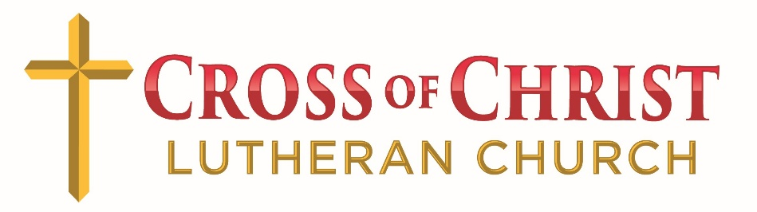



Welcome to worship at Cross of Christ!
In the Cross of Christ I glory

Second Sunday After Pentecost
June 7, 2026

(* Please stand as you are able)

Prelude

Greetings and Announcements

*Brief Order For Confession and Forgiveness

P: In the name of the Father, and of the Son, and of the Holy Spirit.
C: Amen

P: Almighty God, to whom all hearts are open, all desires known, and from whom no secrets are hid: Cleanse the thoughts of our hearts by the inspiration of your Holy Spirit, that we may perfectly love you and worthily magnify your holy name, through Jesus Christ our Lord.
C: Amen

P: If we say we have no sin, we deceive ourselves, and the truth is not in us. But if we confess our sins, God who is faithful and just will forgive our sins and cleanse us from all unrighteousness.

Silence for reflection and self-examination.

P: Most merciful God,
C: we confess that we are in bondage to sin and cannot free ourselves. We have sinned against you in thought, word, and deed, by what we have done and by what we have left undone. We have not loved you with our whole heart; we have not loved our neighbors as ourselves. For the sake of your Son, Jesus Christ, have mercy on us. Forgive us, renew us, and lead us, so that we may delight in your will and walk in your ways, to the glory of your holy name. Amen

P: Almighty God, in his mercy, has given his Son to die for us and, for his sake, forgives us all our sins. As a called and ordained minister of the Church of Christ, and by his authority, I therefore declare to you the entire forgiveness of all your sins, in the name of the Father, and of the Son, and of the Holy Spirit.
C: Amen

* OPENING HYMN “Joyful, Joyful We Adore Thee” LBW 551

*Apostolic Greeting

P: The grace of our Lord Jesus Christ, the love of God, and the communion of the Holy Spirit be with you all.
C: And also with you.
*Kyrie
*Hymn of Praise: “This is the Feast”

*Salutation
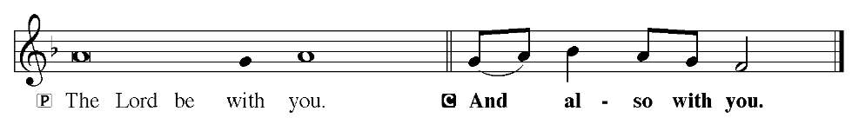
*Prayer of the Day
P: O God, you are the protector of all who trust in you, and beside you, nothing is strong or holy. Multiply your mercy and guide us that while using the good things of this fleeting life, we do not lose hold of the things that endure forever. Grant this, we pray, through Jesus Christ, your Son, our Lord, who lives and reigns with you and the Holy Spirit, one God, now and forever.
C: Amen.

Children dismissed for children's church

First Reading: Hosea 5:15-6:6 (ESV)
I will return again to my place, until they acknowledge their guilt and seek my face, and in their distress earnestly seek me. ⁶ “Come, let us return to the Lord; for he has torn us, that he may heal us; he has struck us down, and he will bind us up. ² After two days he will revive us; on the third day he will raise us up, that we may live before him.
³ Let us know; let us press on to know the Lord; his going out is sure as the dawn; he will come to us as the showers, as the spring rains that water the earth.” ⁴ What shall I do with you, O Ephraim? What shall I do with you, O Judah? Your love is like a morning cloud, like the dew that goes early away. ⁵ Therefore I have hewn them by the prophets; I have slain them by the words of my mouth, and my judgment goes forth as the light. ⁶ For I desire steadfast love and not sacrifice, the knowledge of God rather than burnt offerings.

The Word of God for the people of God!
C: Thanks be to God!

Psalm 119:65-72 Read Responsively by Verse
⁶⁵ You have dealt well with your servant,
O Lord, according to your word.
⁶⁶ Teach me good judgment and knowledge,
for I believe in your commandments.
⁶⁷ Before I was afflicted I went astray,
but now I keep your word.
⁶⁸ You are good and do good;
teach me your statutes.
⁶⁹ The insolent smear me with lies,
but with my whole heart I keep your precepts;
⁷⁰ their heart is unfeeling like fat,
but I delight in your law.
⁷¹ It is good for me that I was afflicted,
that I might learn your statutes.
⁷² The law of your mouth is better to me
than thousands of gold and silver pieces.

Second Reading: Romans 4:13-25 (ESV)
¹³ For the promise to Abraham and his offspring that he would be heir of the world did not come through the law but through the righteousness of faith. ¹⁴ For if it is the adherents of the law who are to be the heirs, faith is null and the promise is void. ¹⁵ For the law brings wrath, but where there is no law there is no transgression. ¹⁶ That is why it depends on faith, in order that the promise may rest on grace and be guaranteed to all his offspring—not only to the adherent of the law but also to the one who shares the faith of Abraham, who is the father of us all, ¹⁷ as it is written, “I have made you the father of many nations”—in the presence of the God in whom he believed, who gives life to the dead and calls into existence the things that do not exist. ¹⁸ In hope he believed against hope, that he should become the father of many nations, as he had been told, “So shall your offspring be.” ¹⁹ He did not weaken in faith when he considered his own body, which was as good as dead (since he was about a hundred years old), or when he considered the barrenness of Sarah's womb. ²⁰ No unbelief made him waver concerning the promise of God, but he grew strong in his faith as he gave glory to God, ²¹ fully convinced that God was able to do what he had promised. ²² That is why his faith was “counted to him as righteousness.” ²³ But the words “it was counted to him” were not written for his sake alone, ²⁴ but for ours also. It will be counted to us who believe in him who raised from the dead Jesus our Lord, ²⁵ who was delivered up for our trespasses and raised for our justification.

The Word of God for the people of God!
C: Thanks be to God!

*Gospel Acclamation
P: The Holy Gospel according to St. Matthew, the 9th chapters.

The Holy Gospel: Matthew 9:9-13 (ESV)
As Jesus passed on from there, he saw a man called Matthew sitting at the tax booth, and he said to him, “Follow me.” And he rose and followed him. ¹⁰ And as Jesus reclined at table in the house, behold, many tax collectors and sinners came and were reclining with Jesus and his disciples. ¹¹ And when the Pharisees saw this, they said to his disciples, “Why does your teacher eat with tax collectors and sinners?” ¹² But when he heard it, he said, “Those who are well have no need of a physician, but those who are sick. ¹³ Go and learn what this means: ‘I desire mercy, and not sacrifice.’ For I came not to call the righteous, but sinners.”

This is the Gospel of our Lord.

Sermon Pastor Carl Haynes

*Sermon Hymn “My Faith Looks Up To Thee” LBW 479

*Nicene Creed
We believe in one God,
the Father, the Almighty,
maker of heaven and earth,
of all that is, seen and unseen.
We believe in one Lord, Jesus Christ,
the only Son of God,
eternally begotten of the Father,
God from God, Light from Light,
true God from true God,
begotten, not made,
of one Being with the Father.
Through him all things were made.
For us and for our salvation
he came down from heaven;
by the power of the Holy Spirit
he became incarnate from the virgin Mary and was made man.
For our sake he was crucified under Pontius Pilate;
he suffered death and was buried.
On the third day he rose again
in accordance with the Scriptures;
he ascended into heaven
and is seated at the right hand of the Father.
He will come again in glory to judge the living and the dead,
and his kingdom will have no end.
We believe in the Holy Spirit, the Lord, the giver of life,
who proceeds from the Father and the Son.
With the Father and the Son he is worshipped and glorified.
He has spoken through the prophets.
We believe in one holy catholic and apostolic Church.
We acknowledge one Baptism for the forgiveness of sins.
We look for the resurrection of the dead,
and the life of the world to come. Amen

*Prayer of the Church

*Receiving of our Tithes and Offerings

*The Offertory
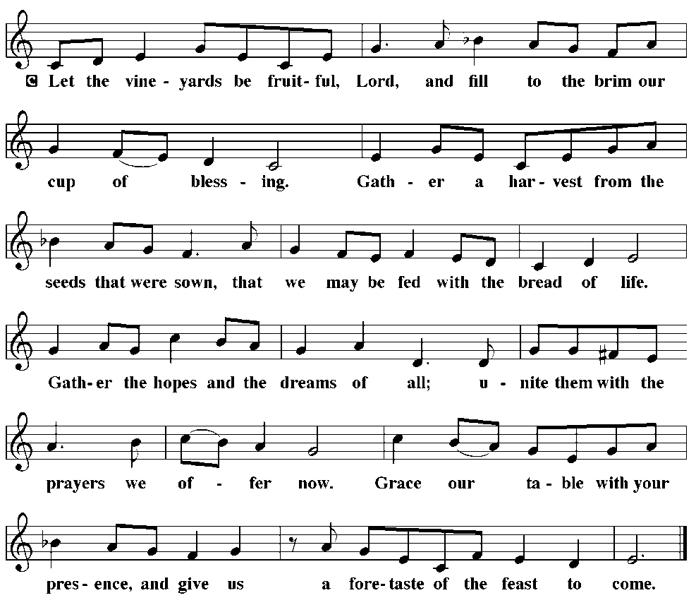

*Offertory Prayer
P: Let us pray. Merciful Father,
C: we offer with joy and thanksgiving what you have first given us-- ourselves, our time, and our possessions, signs of your gracious love. Receive them for the sake of him who offered himself for us, Jesus Christ our Lord. Amen

*The Great Thanksgiving
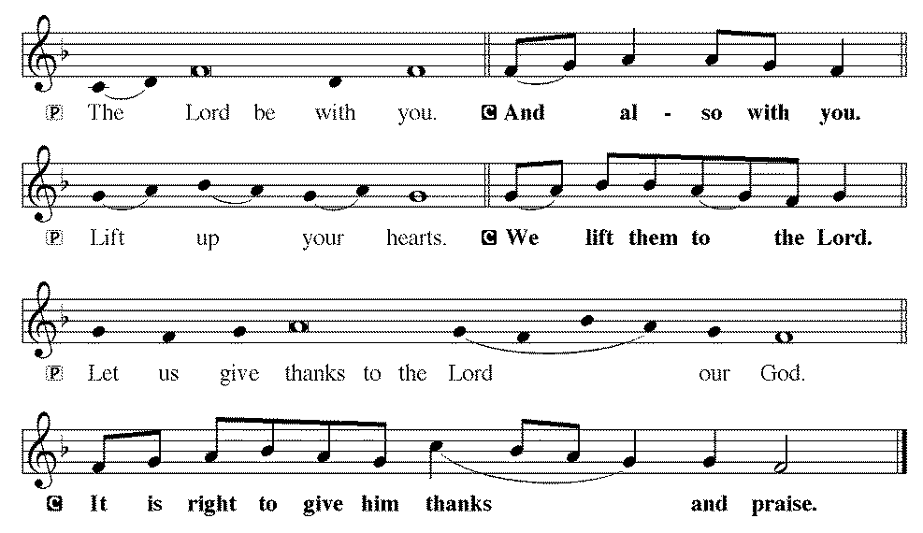
P: It is indeed right and salutary...we praise your name and
join their unending hymn:
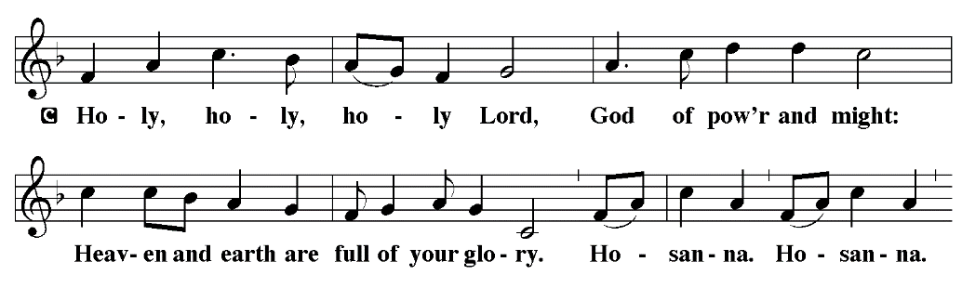
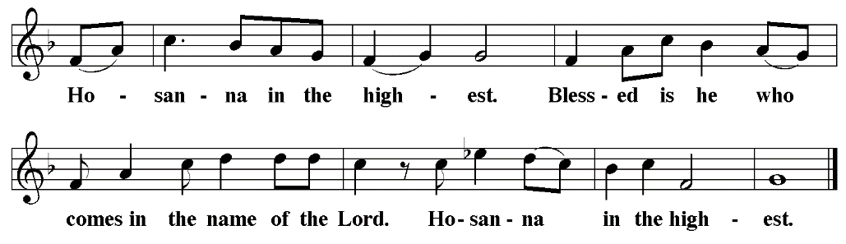

*Eucharistic Prayer & Words of institution
P: Blessed are you, Lord of heaven and earth.
In mercy for our fallen world you gave your only Son,
that all those who believe in him
should not perish but have eternal life.
We give thanks to you
for the salvation you have prepared for us through Jesus Christ.
Send now your Holy Spirit into our hearts,
that we may receive our Lord with a living faith
as he comes to us in his holy supper.
C: Amen. Come, Lord Jesus.
P: In the night in which he was betrayed,
our Lord Jesus took bread, and gave thanks;
broke it, and gave it to his disciples, saying:
Take and eat; this is my body, given for you.
Do this for the remembrance of me.
Again, after supper, he took the cup, gave thanks,
and gave it for all to drink, saying:
This cup is the new covenant in my blood,
shed for you and for all people for the forgiveness of sin.
Do this for the remembrance of me.

*The Lord's Prayer
Our Father, who art in heaven, hallowed be thy name,
thy kingdom come,
thy will be done,
on earth as it is in heaven.
Give us this day our daily bread;
and forgive us our trespasses,
as we forgive those who trespass against us;
and lead us not into temptation,
but deliver us from evil.
For thine is the kingdom, and the power, and the glory,
forever and ever. Amen
Administration of the Holy Sacrament

Communion Hymns WOV 740 & 709

*Post Communion Blessing
P: The body and blood of our Lord Jesus Christ
strengthen you and keep you in his grace.
C: Amen

*Post Communion Canticle: “Thank the Lord”
*Post Communion Prayer
P: Let us pray. We give you thanks, almighty God, that you have refreshed us through the healing power of this gift of life; and we pray that in your mercy you would strengthen us through this gift, in faith toward you and fervent love toward one another; for the sake of Jesus Christ our Lord.
C: Amen

*Benediction
P: The Lord bless you and keep you.
The Lord make his face shine on you and be gracious to you.
The Lord look upon you with favor and give you peace.
C: Amen

*Sending Hymn “Sent Forth By God’s Blessing” LBW 221

*Dismissal

P: Go in peace. Serve the Lord.
C: Thanks be to God.

The Alter Flowers are given to the glory of God and in honor of Marianna Harrison’s 20th Birthday by Mom, Dad, Emma, and Justin.

There will be no PBnJ Youth meeting on June 14th.

The PBnJ Youth group will be going to the Life Center on July 2nd at 10:30 to play BINGO.

VBS – 2026 July 6-10, 6:00-8:30 Ages 2 - 5th Grade
If you would like to help, please contact Meredith Harrison.
Below is a link for snack items that are needed for VBS. All items need to be to Meredith by July 1, 2026. Thank you for your help.
https://www.signupgenius.com/go/10C0445AFAC2CAAFDC34-64296670-vbs2026

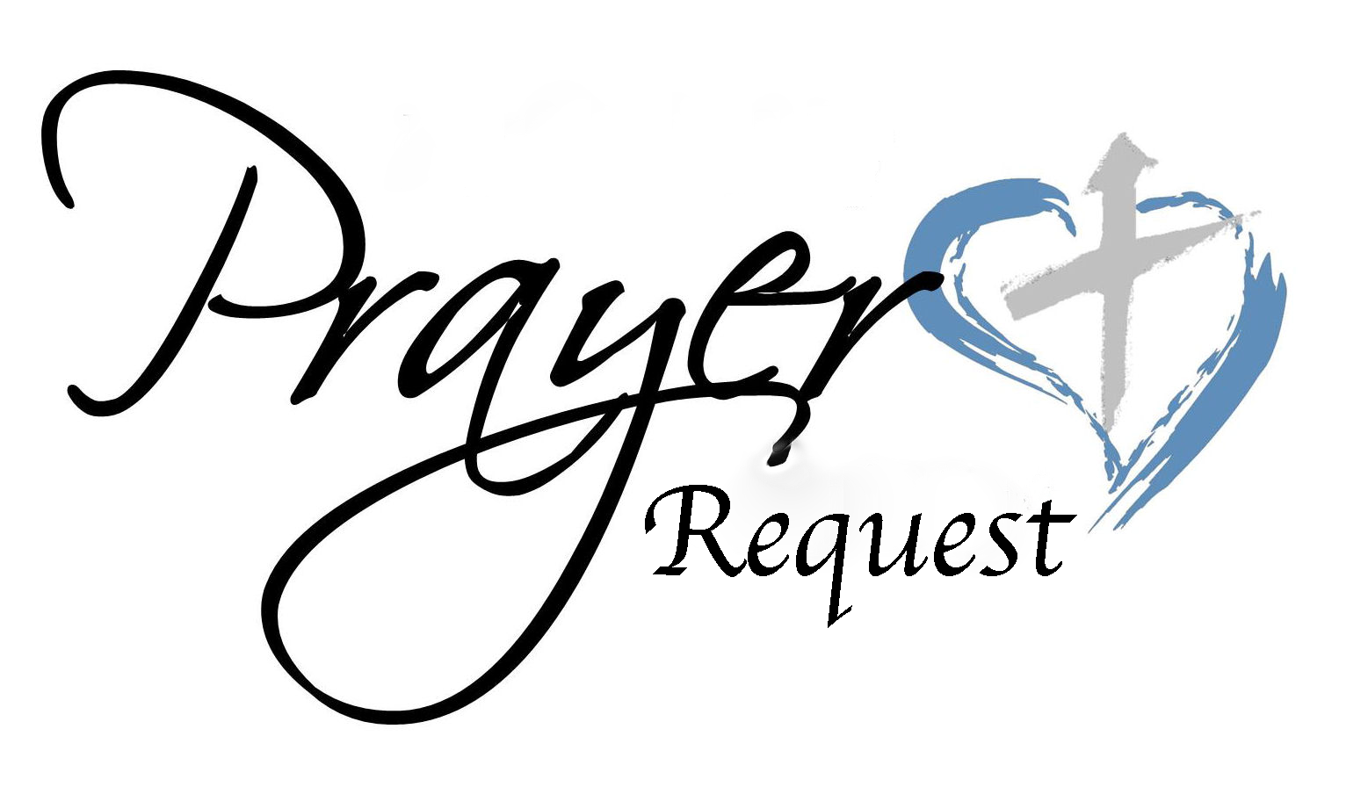
June 7, 2026
We ask that you always have an individual’s permission before
requesting their name be added to our Prayer List.
Please send prayer list request additions or changes to
prayercclc@gmail.com by Tuesday 5PM.

First of all, then, I urge that supplications, prayers, intercessions,
and thanksgivings be made for all people… 1Timothy 2:1

In the Fellowship of Cross of Christ
James Bailey; Melvin Bost; Roy Gray; Rand Yost (Rowan Regional – Bronchitis and Bladder infection); Jasper Tidd (son of Kassi Leonard) has fractured the growth plate in his left foot. He will see the ortho doctor on Wednesday.

Call Process prayer requests: 1) Cross of Christ Church; 2) Call Committee; 3) Prospective pastors see our profile/video and consider a call here.

Shut-Ins
Bob & Joann Barrier; Brenda Barrier; Norman Goodman; Nell Hatley;
John Trull

Friends of Cross of Christ
April Funderburke; Lee Gorforth; Candice Horton; Cynthia Horton;
Alicia McQueen; Eric Starling; Susan Starling; Ruthie O’Brien (Friend of Shelbie Bost – Several medical setbacks; brain swelling); Daniel Pless;
Jacob Rodgers; Nick Smith; Bob Wilson; Candace Yates

Carolina Mission Region Seminarians:
Melanie Corn, Robert Dernbach, Lucas Safrit

Serving in the Military
Eaven Allison (Fairbanks, Alaska)

General Prayer Concerns:
· Ongoing Iran war impacts

Praise List:
· Jodie Strube – Thank you for the thoughts and prayers. God is so good.

** Please remember our shut-ins with a visit, phone call,
cards, or email along with your prayers

Today – June 7, 2026

Sunday Church School 9:00 AM
Holy Communion Service 10:00 AM

THIS WEEK
MON: 7-8:30 PM Soldiers of the Cross of Christ Practice

NEXT SUNDAY
9:00 AM Sunday Church School Classes
10:00 AM Family Worship Service

Next Sunday's Readings
Twenty-third Sunday after Pentecost
Malachi 4: 1-6
Psalm 98
2 Thessalonians 3: 1-13
St. Luke 21: 5-28

Next Sunday's Readings
Twenty-third Sunday after Pentecost
Malachi 4: 1-6
Psalm 98
2 Thessalonians 3: 1-13
St. Luke 21: 5-28

Next Sunday's Readings
Twenty-third Sunday after Pentecost
Malachi 4: 1-6
Psalm 98
2 Thessalonians 3: 1-13
St. Luke 21: 5-28

Next Sunday's Readings
Twenty-third Sunday after Pentecost
Malachi 4: 1-6
Psalm 98
2 Thessalonians 3: 1-13
St. Luke 21: 5-28

Next Sunday's Readings
Twenty-third Sunday after Pentecost
Malachi 4: 1-6
Psalm 98
2 Thessalonians 3: 1-13
St. Luke 21: 5-28

Next Sunday's Readings
Third Sunday After Pentecost
Exodus 19:2-8a
Psalm 100:1-5
Romans 5:6-15
St. Matthew 9:35-10:8, 9-20

Next Sunday's Readings
Twenty-third Sunday after Pentecost
Malachi 4: 1-6
Psalm 98
2 Thessalonians 3: 1-13
St. Luke 21: 5-28

Next Sunday's Readings
Twenty-third Sunday after Pentecost
Malachi 4: 1-6
Psalm 98
2 Thessalonians 3: 1-13
St. Luke 21: 5-28

www.crossofchristlutheranchurch.org
http://www.facebook.com/CrossofChristLutheranChurchConcord
ClericalTeam@Gmail.com
prayercclc@gmail.com

